Ardeley St Lawrence C of E Primary School

Newsletter

24 June 2022
Dear Parents,
Good news…
Well done to these children for earning these certificates for their hard work and fantastic attitudes.
BLUE: Rohan, Isaac R, Amelie J, Felix
INDIGO: Zach, Jacob, Dougie, Jack W

EYFS Star of the week: Opie
Lunchtime Stars: Dougie and Milo

KS2 enjoyed a visit from the Pakiki theatre company to learn about the history of Hertfordshire. Everyone learnt a lot of new facts!
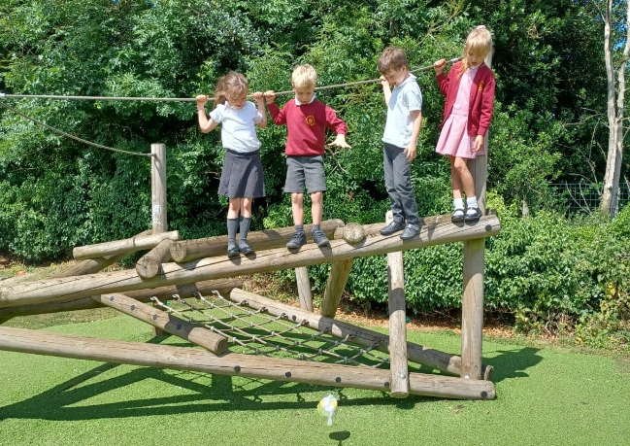
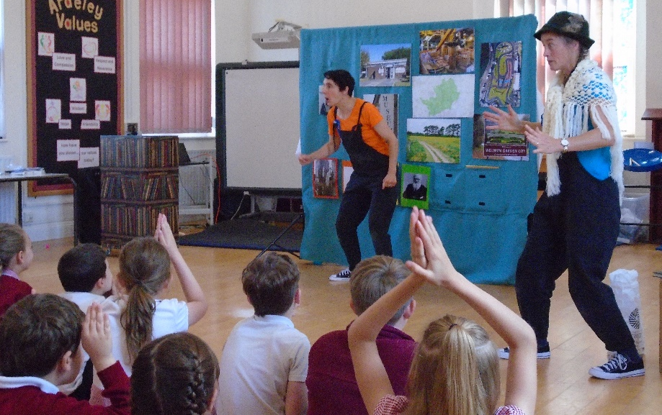
KS1 have been doing science experiments, finding out which material best protects an egg when dropped from a height! EYFS have been learning all about minibeasts like spiders and ladybirds.

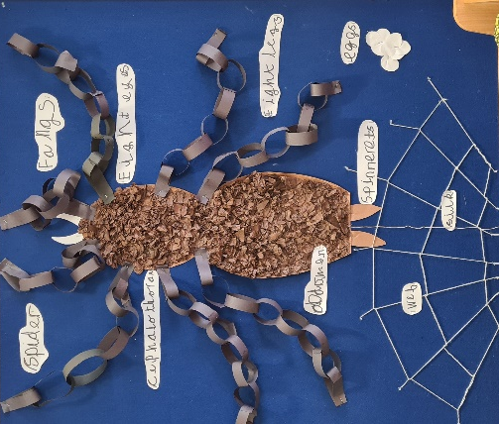

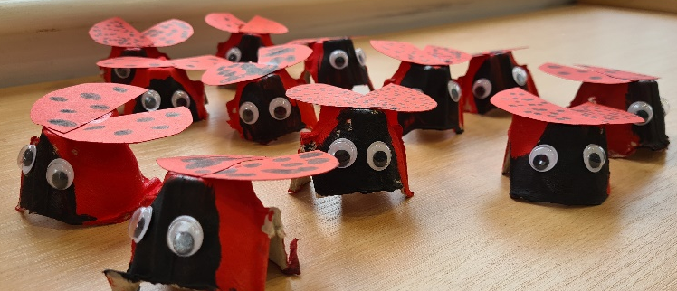

Uniform…
Thank you for the efforts you have made to ensure the uniform expectations are met. The children look very smart. Just a reminder that cycling shorts are only allowed for PE & Forest School days please. Hair should be tied back and children sent in with a hat & sun cream applied before they come to school. School shoes should be black & worn every day apart from PE days. Children need a water bottle every day.

Arbor…
As you know we have started to make the switch to Arbor (along with Jotter) for school communications. Please sign up – Miss Mullins has sent everyone an invitation email with the links needed. Please note online payments can only be made through Wisepay at the moment, while we set up the new payment systems.

Rota & curriculum…
The next two weeks are as follows:
Week A – 27 June – 1 July
Tuesday – FOREST SCHOOL – OLDER CLOTHES |  | Thursday – PE – COME IN PE KIT
UKS2 (1 hr) | KS1 | LKS2 (AM) | UKS2

Week B – 4th – 8th July
Tuesday – FOREST SCHOOL – OLDER CLOTHES |  | Thursday – PE - COME IN PE KIT
UKS2 (1hr) | LKS2 | KS1 | EYFS

Events…
This is a very busy time of the year, with lots of events and dates for the Diary. Please ensure you read the newsletter each week, including the dates at the end and check book bags regularly for permission slips etc. Thank you.

OUR BIGGEST FUNDRAISER OF THE YEAR IS TOMORROW!
The Village Fete raises a HUGE amount of money which we rely on to complete building works around the school. This year we desperately need to raise money for a new School Boiler as ours is on its last legs!

PLEASE DO COME ALONG!
We already have some children opening the fete with the steel drums and the maypole. Thank you to them and to their families! Performers should arrive at the village Green at 2.15pm in school uniform please.

YOUR SUPPORT IS ESSENTIAL!

We have a full, fun packed Summer Term remaining with lots of other events and trips. Please do check your newsletter and Jotter reminders to keep up with it all! Letters will come out for all events so do check book bags!

Finally…
This week Father Mark visited us to teach the children about the Trinity. The children enjoyed the worship and understood how God is represented by God the Father, God the Son and God the Holy Spirit.
With kind regards
Mrs Connolly

Summer Term Dates

Ardeley Summer Fete Saturday 25 June 2.30pm
Performers – please arrive at 2.15pm on the Village Green, in school uniform.

LKS2 to Bennington Church (lesson) Wednesday 29 June PM

Year 1 trip to Shepreth Friday 1 July
UKS2 to Henry Moore

‘New to’ Reception Parents Information session Monday 4 July 5pm

Year 3/4 Mini Olympics Thursday 7 July AM
EYFS transition day (new children in)

Camp Out Friday 8 July

Summer Show Matinee Tuesday 12 July

Summer Show Evening Performance Wednesday 13 July

Transition Day (Y1-6) Thursday 14 July

Year 5/6 to Ardeley Church (lesson) Friday 15 July PM

End of Summer Term Wednesday 20 July 2.30pm

