Ardeley St Lawrence C of E Primary School

Newsletter

17 June 2022
Dear Parents,
Good news…
Well done to these children for earning these certificates for their hard work and fantastic attitudes.
BLUE: Ewan, Alex, Harper
INDIGO: Ella B, Toby, Indie, Annabelle
VIOLET: Lilly-Rose

EYFS Star of the week: Bradley N
Lunchtime Stars: Bradley and Eden

EYFS enjoyed a trip to the farm to feed the animals today. KS1 have been hunting for a tiger (in preparation for their trip) and have been learning to programme Beebots.
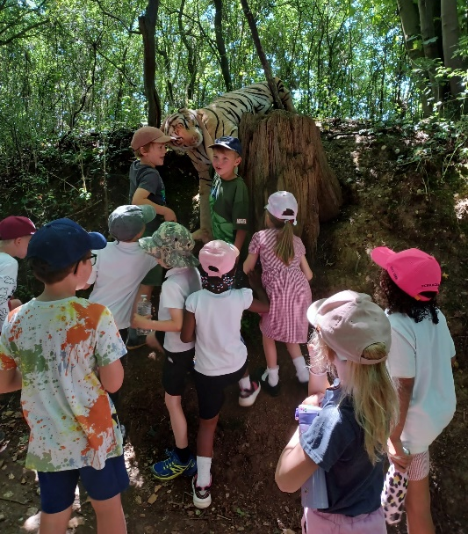

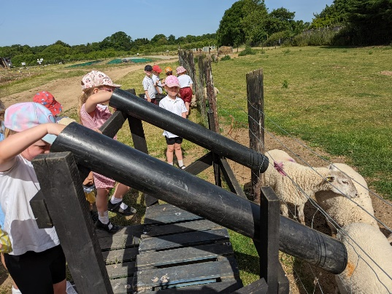

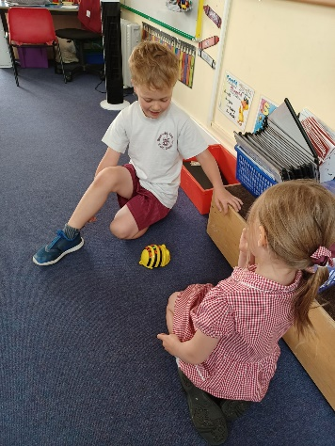

UKS2 have started their backgrounds for their Basquiat work. The LKS2 and UKS2 pupils who spoke to the Diocese today for their Climate Emergency video were excellent and the Diocese were very pleased with their contributions.
All children were extremely sensible in the sun today and followed instructions to stay in the shade. We were fortunate to have a lovely breeze!

Uniform…
As the summer has finally arrived just a reminder about our Summer uniform expectations.
Our summer uniform is grey tailored shorts or skirts, white polo shirts or blouses, summer gingham dresses/culottes. Our PE uniform is burgundy shorts and a white t-shirt. If the weather is very hot we may, as we did today, allow children to wear PE uniform on other days.
Clothes for forest school should be appropriate for the weather & activities. Hair should be tied back and children sent in with a hat & sun cream applied before they come to school. School shoes should be black & worn every day apart from PE days. Children need a water bottle every day.
We did relax our uniform during Covid; however those school level disruptions are behind us so I would ask you to ensure children are dressed as detailed above. Miss Mullins often has a good amount of second hand uniform for sale – please do message her to ask.

Arbor…
As you know we have started to make the switch to Arbor (along with Jotter) for school communications. Please sign up – Miss Mullins has sent everyone an invitation email with the links needed. Please note online payments can only be made through Wisepay at the moment, while we set up the new payment systems.

Rota & curriculum…
The next two weeks are as follows:
Week B – 20th – 24th June
Tuesday – FOREST SCHOOL – OLDER CLOTHES |  | Thursday – PE - COME IN PE KIT
UKS2 (1hr) | LKS2 | KS1 | EYFS

Week A – 27 June – 1 July
Tuesday – FOREST SCHOOL – OLDER CLOTHES |  | Thursday – PE – COME IN PE KIT
UKS2 (1 hr) | KS1 | LKS2 (AM) | UKS2

Events…
This is a very busy time of the year, with lots of events and dates for the Diary. Please ensure you read the newsletter each week, including the dates at the end and check book bags regularly for permission slips etc. Thank you.

OUR BIGGEST FUNDRAISER OF THE YEAR IS ON SATURDAY 25TH JUNE!
The Village Fete raises a HUGE amount of money which we rely on to complete building works around the school. In previous years it has gone towards astro-turf for the EYFS area, new toilets for KS2 and repairs to the bell tower. This year we desperately need to raise money for a new School Boiler as ours is on its last legs!

PLEASE DO COME ALONG!
We already have some children opening the fete with the steel drums and the maypole. Thank you to them and their families!

YOUR SUPPORT IS ESSENTIAL!

We have a full, fun packed Summer Term remaining with lots of other events and trips. Please do check your newsletter and Jotter reminders to keep up with it all! Events and timings will be added as they are confirmed.

Finally…
This week we talked about our Value of Friendship and how we can be a good friend. We thought about how Jesus was a good friend to his disciples. The children reflected on ways they had been good friends and shared examples.
With kind regards
Mrs Connolly

Summer Term Dates

Pakiki Theatre – KS2 (in school) Friday 24 June

Ardeley Summer Fete Saturday 25 June 2.30pm

LKS2 to Bennington Church (lesson) Wednesday 29 June PM

Year 1 trip to Shepreth Friday 1 July
UKS2 to Henry Moore

‘New to’ Reception Parents Information session Monday 4 July 5pm

Year 3/4 Mini Olympics Thursday 7 July AM
EYFS transition day (new children in)

Camp Out (details to follow) Friday 8 July

Summer Show Matinee Tuesday 12 July

Summer Show Evening Performance Wednesday 13 July

Transition Day (Y1-6) Thursday 14 July

Year 5/6 to Ardeley Church (lesson) Friday 15 July PM

End of Summer Term Wednesday 20 July 2.30pm

Covid UPDATE…
Government guidance remains that if someone knows that they have Covid then, out of consideration to others - as would be the case if they had flu, norovirus or any other unpleasant infectious disease - they should stay at home.
The government recommendation is to avoid contact with other people for at least 5 full days and then return to school once they feel better. The government particularly advises this for anyone with a temperature or cough.
Please continue to follow this guidance so we can look after everyone in our community.

HERTS INFORMATION ON COVID-19 vaccination
Vaccination continues to offer the best protection for ourselves and others around us from becoming seriously ill from COVID-19. There are lots of walk-in options available locally for first, second doses and boosters, you can find your nearest vaccination centre and also book an appointment at: https://covid.healthierfuture.org.uk/
The national booking system for healthy 5- to -11 year olds to receive their COVID-19 vaccination will open from 2 April. Parents and carers can book appointments at larger vaccination centres and in some community pharmacies. Appointments will also be available at some GP run sites, if so they will contact you directly and you can book through your practice.
Vaccinations are already available for clinically vulnerable 5- to 11-year-olds, and children in this age group who live with someone who has a weakened immune system. Until now vaccinations for this ‘at risk’ group of children have been available through GPs and special schools, but parents and carers will also be able to book through these through the national booking service from 2 April.

For more information on vaccinations for this age group visit: https://covid.healthierfuture.org.uk/vaccine-information-for-young-people

