Ardeley St Lawrence C of E Primary School

Newsletter

10 June 2022
Dear Parents,
Good news…
Well done to these children for earning these certificates for their hard work and fantastic attitudes. Two weeks’ worth this week!
RED: James
GREEN: Ewan
BLUE: Ayva, Amelia, Seffie, Noah, Harrison, Milo, Leo, Olivia, Harry, Mason, Bradley, Rogue, George, Gabriel, Eliza
INDIGO: Abigail, Lyra-Rae, Rocco
VIOLET: Lyra-Rae, Daniel
RAINBOW: Laylah, Harley, Amelie

EYFS Star of the week: Hermione and Albie
Lunchtime Stars: Grace & Harley

EYFS have started learning about the author Julia Donaldson and this week have been making Gruffalo models and a Gruffalo cave role play area! KS1 have been growing tomatoes, beans and mint, finding enormous caterpillars and hoping for tadpoles…
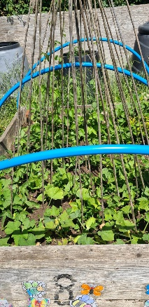
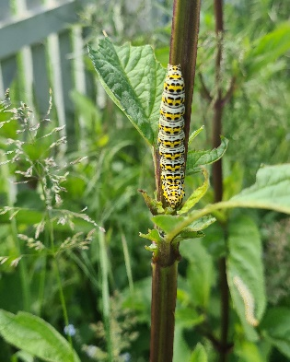
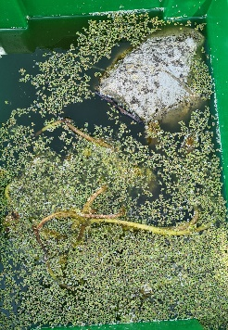
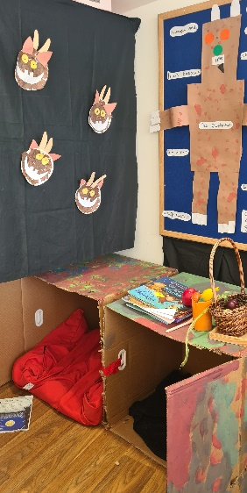
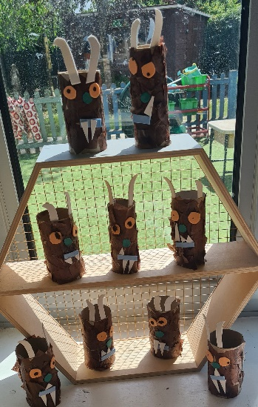
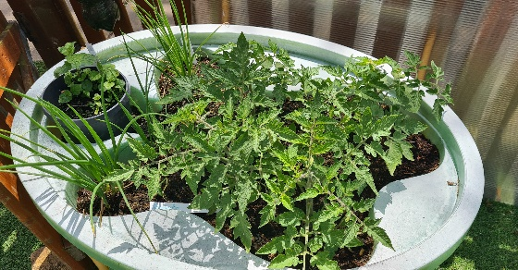
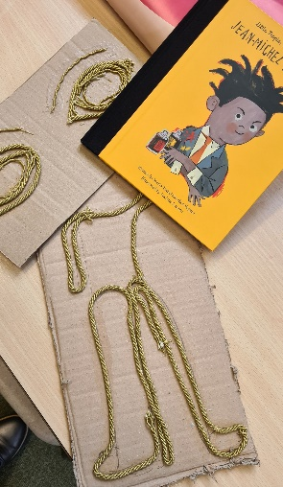
UKS2 are making preparations for
their printing work
based on Jean-Michel
Basquiat and LKS2 have been planning out their DT project this term – making cushions in textiles! We look forward to following this project.

As the weather is changeable, please ensure children bring a light rainproof jacket and a sun hat every day. Sun cream should be applied before school please, as necessary. Please may I also remind you that our school uniform is black shoes, apart from on PE & Forest School days.
Items for show and tell must not be valuable or breakable please.

Events…
OUR BIGGEST FUNDRAISER OF THE YEAR IS ON SATURDAY 25TH JUNE!
The Village Fete raises a HUGE amount of money which we rely on to complete building works around the school. In previous years it has gone towards astro-turf for the EYFS area, new toilets for KS2 and repairs to the bell tower. This year we desperately need to raise money for a new School Boiler as ours is on its last legs!
PLEASE DO COME ALONG!
We already have some children opening the fete with the steel drums and the maypole. Thank you to them and their families!
YOUR SUPPORT IS ESSENTIAL!

We have a full, fun packed Summer Term remaining with lots of other events and trips. Please do check your newsletter and Jotter reminders to keep up with it all! Events and timings will be added as they are confirmed.

Rota & curriculum…
The next two weeks are as follows:

Week A – 13th – 17th June
Tuesday – FOREST SCHOOL – OLDER CLOTHES |  | Thursday – PE – COME IN PE KIT
UKS2 (1 hr) | KS1 | LKS2 (AM) | UKS2

Week B – 20th – 24th June
Tuesday – FOREST SCHOOL – OLDER CLOTHES |  | Thursday – PE - COME IN PE KIT
UKS2 (1hr) | LKS2 | KS1 | EYFS

Finally…
This week we talked about Pentecost and how the Disciples never felt alone with the Holy Spirit within them. They used the strength the Holy Spirit gave them to share the good news about Jesus.
“After they prayed, the place where they were meeting was shaken. And they were all filled with the Holy Spirit and spoke the word of God boldly.” Acts 4:31
With kind regards
Mrs Connolly

Summer Term Dates

Ardeley Summer Fete Saturday 25 June

Year 1 trip to Shepreth Friday 1 July

‘New to’ Reception Parents Information session Monday 4 July

Summer Show Matinee Tuesday 12 July

Summer Show Evening Performance Wednesday 13 July

Transition Day (Y1-6) Thursday 14 July

End of Summer Term Wednesday 20 July 2.30pm

Covid UPDATE…
Government guidance remains that if someone knows that they have Covid then, out of consideration to others - as would be the case if they had flu, norovirus or any other unpleasant infectious disease - they should stay at home.
The government recommendation is to avoid contact with other people for at least 5 full days and then return to school once they feel better. The government particularly advises this for anyone with a temperature or cough.
Please continue to follow this guidance so we can look after everyone in our community.

HERTS INFORMATION ON COVID-19 vaccination
Vaccination continues to offer the best protection for ourselves and others around us from becoming seriously ill from COVID-19. There are lots of walk-in options available locally for first, second doses and boosters, you can find your nearest vaccination centre and also book an appointment at: https://covid.healthierfuture.org.uk/
The national booking system for healthy 5- to -11 year olds to receive their COVID-19 vaccination will open from 2 April. Parents and carers can book appointments at larger vaccination centres and in some community pharmacies. Appointments will also be available at some GP run sites, if so they will contact you directly and you can book through your practice.
Vaccinations are already available for clinically vulnerable 5- to 11-year-olds, and children in this age group who live with someone who has a weakened immune system. Until now vaccinations for this ‘at risk’ group of children have been available through GPs and special schools, but parents and carers will also be able to book through these through the national booking service from 2 April.

For more information on vaccinations for this age group visit: https://covid.healthierfuture.org.uk/vaccine-information-for-young-people

