Ardeley St Lawrence C of E Primary School

Newsletter

13 May 2022
Dear Parents,
Good news…

Well done to these children for earning their certificates for hard work and fantastic attitudes:
YELLOW: Alice
GREEN: Hailey, Isaac R
BLUE: Zach, Jacob, Ella B, Lyra-Rae, Annabelle, Indie, Hudson

EYFS Star of the week: Jess
Lunchtime Stars: Oscar & James

This week we have had Scootability for Year 2, Year 1 and LKS2 have been lamb feeding, UKS2 had a post SATS wellbeing walk and also completed some wonderful Egyptian artwork:
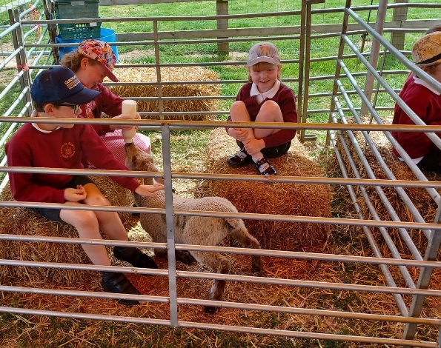
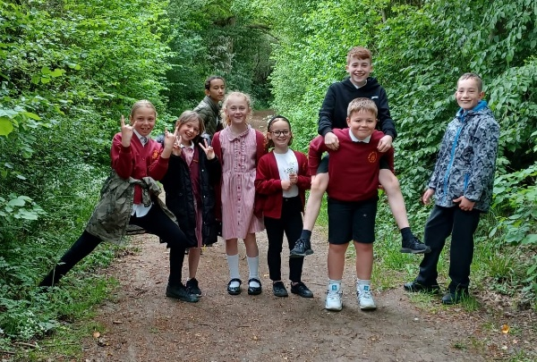

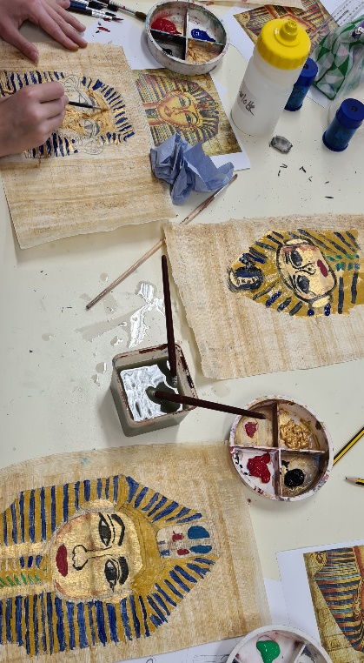

Events…
- We have our Sports Day planned on 19th May. Gates will open at 1.15pm and the events will start at 1.30pm. It will be a similar format to last year, except all the children will be together – they will still race in age appropriate groups. Races will be run from either end of the tracks so everyone has a good view.
- Next week is also Ardeley’s “Walk Week”. Nationally, it is Walk to School week – we know this is possible for some of our families and not possible for many others! So we have challenged you to walk more of a local route – perhaps to the shops or a swimming lesson, or to football practice. Letters came home today with a form for children to record their successes on!
- Letters have gone out regarding the school Jubilee celebration, on 26th May in the afternoon.
- The Term Dates for next year are now on the website.
- There is a road closure planned for Monday and Tuesday. Unfortunately we were not notified of this. You can come in via the road next to the Cromer Windmill. We hope the road may be open before school starts but we cannot promise!
- Next term we will teach the Relationships and Sex Education curriculum to our pupils. This is taught in Year groups as it is age appropriate. We will be using the recognised and award winning, Christopher Winter Project scheme of work. Please do contact us if you would like further information.

Rota & curriculum…
The next two weeks are as follows:
Week B – 16th - 20th May
Tuesday – FOREST SCHOOL – OLDER CLOTHES |  | Thursday – PE - COME IN PE KIT
UKS2 (1hr) | LKS2 | EVERYONE FOR SPORTS DAY

Week A – 23rd – 26th May
Tuesday – FOREST SCHOOL – OLDER CLOTHES |  | Thursday – PE – COME IN PE KIT
UKS2 (1 hr) | KS1 | LKS2 | UKS2 (Jubilee picnic)

As the weather is changeable please ensure children bring a light rainproof jacket and a sun hat every day. Sun cream should be applied before school please, as necessary.

Finally…
This week we have been thinking about the bravery showed by Peter in continuing to spread the word of God after the crucifixion.
Joshua 1:9: Be strong and courageous. Do not be frightened, and do not be dismayed, for the LORD your God is with you wherever you go.”
With kind regards
Mrs Connolly

Summer Term Dates

Ardeley ‘Walk Week’ Monday – Friday 20 May

Sports day – 1.30pm Thursday 19 May

Last day of half term & Jubilee tea party Thursday 26 May

Extra Platinum Bank holiday day (in lieu) school closed. Friday 27 May

Return to school Monday 6 June

End of Summer Term Wednesday 20 July 2.30pm

Covid UPDATE…
Government guidance remains that if someone knows that they have Covid then, out of consideration to others - as would be the case if they had flu, norovirus or any other unpleasant infectious disease - they should stay at home.
The government recommendation is to avoid contact with other people for at least 5 full days and then return to school once they feel better. The government particularly advises this for anyone with a temperature or cough.
Please continue to follow this guidance so we can look after everyone in our community.

HERTS INFORMATION ON COVID-19 vaccination
Vaccination continues to offer the best protection for ourselves and others around us from becoming seriously ill from COVID-19. There are lots of walk-in options available locally for first, second doses and boosters, you can find your nearest vaccination centre and also book an appointment at: https://covid.healthierfuture.org.uk/
The national booking system for healthy 5- to -11 year olds to receive their COVID-19 vaccination will open from 2 April. Parents and carers can book appointments at larger vaccination centres and in some community pharmacies. Appointments will also be available at some GP run sites, if so they will contact you directly and you can book through your practice.
Vaccinations are already available for clinically vulnerable 5- to 11-year-olds, and children in this age group who live with someone who has a weakened immune system. Until now vaccinations for this ‘at risk’ group of children have been available through GPs and special schools, but parents and carers will also be able to book through these through the national booking service from 2 April.

For more information on vaccinations for this age group visit: https://covid.healthierfuture.org.uk/vaccine-information-for-young-people

