Ardeley St Lawrence C of E Primary School

Newsletter

6 May 2022
Dear Parents,
Good news…

Well done to these children for earning their certificates for hard work and fantastic attitudes:
YELLOW: Raphy
GREEN: Poppy, Amelie, Felix, Grace, Arthur, Theo
BLUE: Jack W
INDIGO: Daniel

EYFS Star of the week: Azra
Lunchtime Stars: Isaac Mc & Eliza

EYFS have been making scarecrows to protect their seeds, Year 2 have been lamb feeding, LKS2 have been using Kadinsky as inspiration to create multi-media pictures and UKS2 have been working on pulley systems, creating a prototype for pulling water from a well:
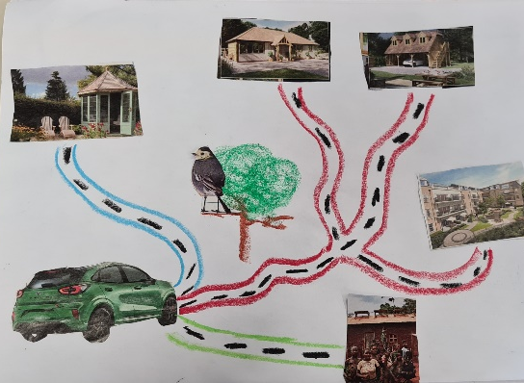
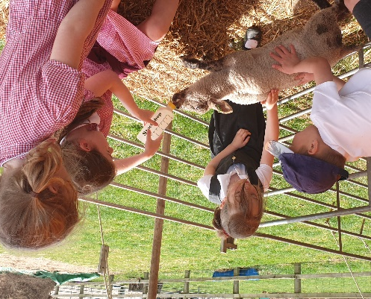

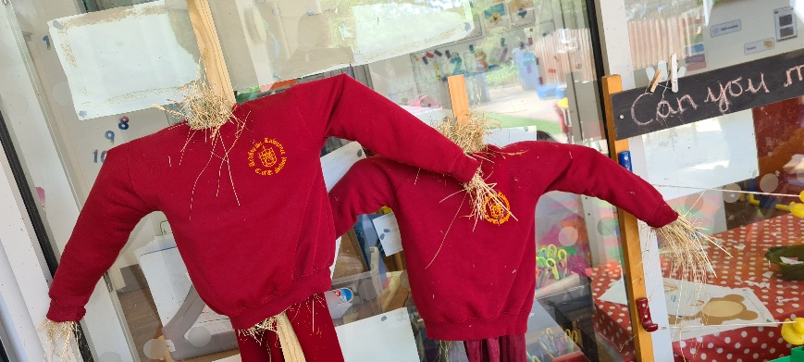
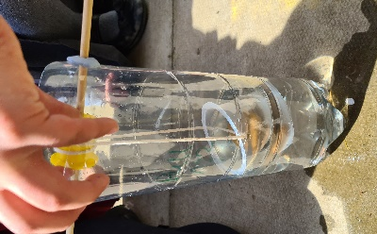

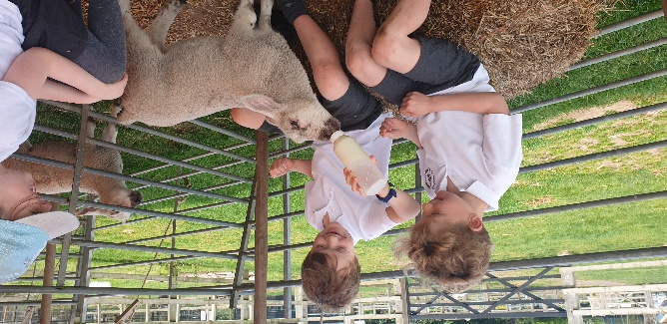

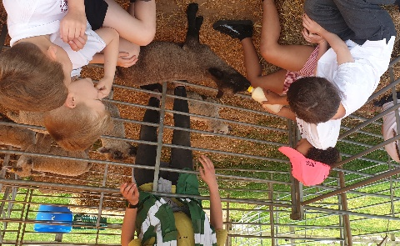

All the children have been learning about the steps they can take to reduce their waste in their PSHE Environment topic last term. This week in assembly we looked at the Blue Peter Climate Hero Pledges and all made a Power pledge, a Plastic pledge and a Plant pledge to help the environment. Please do ask your children to share their pledge ideas with you. Carrying out these pledges will likely qualify for earning a Blue Peter Green Badge. If any children have one already or do earn one, please do bring them in to share and celebrate in Mrs Templeton's assembly.
Three Pledges | How to look after the environment | How to get a Blue Peter Green Badge - CBBC - BBC

Events…
- SATS are next week for Year 6 – a letter has been emailed out to parents of Y6 children explaining the arrangements. Year 2 SATS will take place over May – these are kept very low key.
- Year 2 will be taking part in ‘Scootability’ – on Friday 13th May in the afternoon.
- Year 1 and LKS2 have their lamb feeding next week.
- We have our Sports Day planned on 19th May. Gates will open at 1.15pm and the events will start at 1.30pm. It will be a similar format to last year, except all the children will be together – they will still race in age appropriate groups. Races will be run from either end of the tracks so everyone has a good view.
- Letters have gone out regarding the school Jubilee celebration, on 26th May in the afternoon.
- The Term Dates for next year are now on the website.

Rota & curriculum…
The next two weeks are as follows:
Week A – 9th – 13th May
Tuesday – FOREST SCHOOL – OLDER CLOTHES |  | Thursday – PE – COME IN PE KIT
UKS2 (1 hr) | KS1 | LKS2 | UKS2

Week B – 16th - 20th May
Tuesday – FOREST SCHOOL – OLDER CLOTHES |  | Thursday – PE - COME IN PE KIT
UKS2 (1hr) | LKS2 | EVERYONE FOR SPORTS DAY

As the weather is set to be nice but changeable please ensure children bring a light jacket and a sun hat every day. Sun cream should be applied before school please, as necessary.

Finally…
This week we have been thinking about the forgiveness that Jesus showed Paul, as he struggled to believe after the crucifixion and thought about who we forgive and how we need to ask for forgiveness.
Daniel 9:9: "The Lord our God is merciful and forgiving…”
With kind regards
Mrs Connolly

Summer Term Dates

SATS week – Y6 9 -12 May

Year 2 ‘Scootability’ 13 May

Sports day – 1.30pm Thursday 19 May

Last day of half term & Jubilee tea party Thursday 26 May

Extra Platinum Bank holiday day (in lieu) school closed. Friday 27 May

Return to school Monday 6 June

End of Summer Term Wednesday 20 July 2.30pm

Covid UPDATE…
Government guidance remains that if someone knows that they have Covid then, out of consideration to others - as would be the case if they had flu, norovirus or any other unpleasant infectious disease - they should stay at home.
The government recommendation is to avoid contact with other people for at least 5 full days and then return to school once they feel better. The government particularly advises this for anyone with a temperature or cough.
Please continue to follow this guidance so we can look after everyone in our community.

HERTS INFORMATION ON COVID-19 vaccination
Vaccination continues to offer the best protection for ourselves and others around us from becoming seriously ill from COVID-19. There are lots of walk-in options available locally for first, second doses and boosters, you can find your nearest vaccination centre and also book an appointment at: https://covid.healthierfuture.org.uk/
The national booking system for healthy 5- to -11 year olds to receive their COVID-19 vaccination will open from 2 April. Parents and carers can book appointments at larger vaccination centres and in some community pharmacies. Appointments will also be available at some GP run sites, if so they will contact you directly and you can book through your practice.
Vaccinations are already available for clinically vulnerable 5- to 11-year-olds, and children in this age group who live with someone who has a weakened immune system. Until now vaccinations for this ‘at risk’ group of children have been available through GPs and special schools, but parents and carers will also be able to book through these through the national booking service from 2 April.

For more information on vaccinations for this age group visit: https://covid.healthierfuture.org.uk/vaccine-information-for-young-people

