Ardeley St Lawrence C of E Primary School

Newsletter

29 April 2022
Dear Parents,
Good news…

Well done to these children for earning these certificates for their hard work and fantastic attitudes:
BLUE: Lilly-Rose, Toby
INDIGO: Mei, Amber
VIOLET: Lillie-May

EYFS Star of the week: Albie
Lunchtime Stars: Hailey &

This week LKS2 finally attended their Tag Rudgy Festival, EYFS have been making rangoli patterns as part of their India topic and EYFS & UKS2 have been lamb feeding. UKS2 also ran some play leader sessions with KS1:
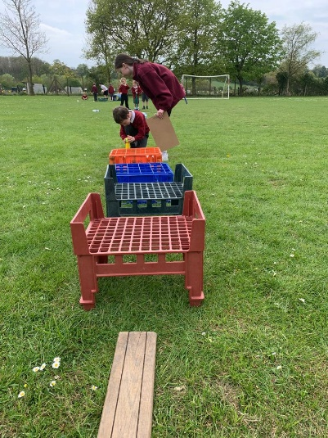
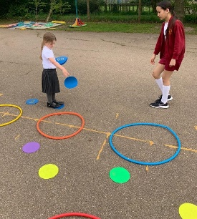
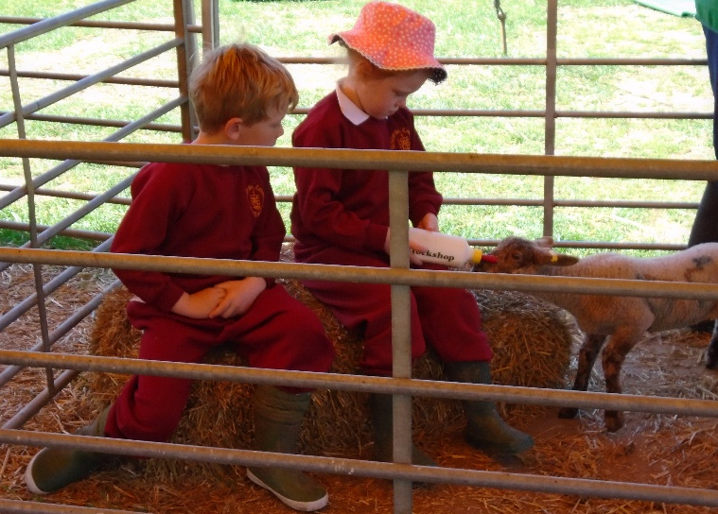

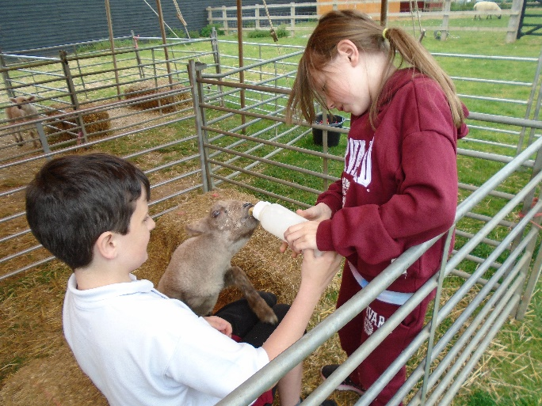

All the children have been learning about the steps they can take to reduce their waste in their PSHE Environment topic last term. This week in assembly we looked at the Blue Peter Climate Hero Pledges and all made a Power pledge, a Plastic pledge and a Plant pledge to help the environment. Please do ask your children to share their pledge ideas with you. Carrying out these pledges will likely qualify for earning a Blue Peter Green Badge. If any children have one already or do earn one, please do bring them in to share and celebrate in Mrs Templeton's assembly.
Three Pledges | How to look after the environment | How to get a Blue Peter Green Badge - CBBC - BBC

Events…
- We have our Sports Day planned on 19th May and will send out more information nearer to the time.
- We are also having a school Jubilee celebration, on 26th May in the afternoon. The Governors and FAS are arranging it, with entertainment, ice creams, and ‘bring your own’ picnics.
- Year 2 will be taking part in ‘Scootability’ – on Friday 13th May in the afternoon – a separate letter will come out soon. Year 1 will have this next year.
- The Term Dates for next year are now on the website.

Rota & curriculum…

The next two weeks are as follows:
Week B – 3rd – 6th May
Tuesday – FOREST SCHOOL – OLDER CLOTHES |  | Thursday – PE - COME IN PE KIT
UKS2 (1hr) | LKS2 | KS1 | EYFS

Week A – 9th – 13th May
Tuesday – FOREST SCHOOL – OLDER CLOTHES |  | Thursday – PE – COME IN PE KIT
UKS2 (1 hr) | KS1 | LKS2 | UKS2

Finally…
This week we have been thinking about kindness and also how we can show that kindness, not only to each other, but to the world. We spent time reflecting on what we have done this week but also thinking about how we can be evern better next week, using the lessons on the bible to help us.

“Teach me to do your will, for you are my God, may your good Spirit lead me on level ground.”
Psalm 143:10
Enjoy your Bank Holiday weekend!
With kind regards
Mrs Connolly

Summer Term Dates

Bank Holiday Monday 2 May

SATS week 9 -12 May

Year 2 ‘Scootability’ 13 May

Sports day Thursday 19 May

Last day of half term & Jubilee tea party Thursday 26 May

Extra Platinum Bank holiday day (in lieu) school closed. Friday 27 May

Return to school Monday 6 June

End of Summer Term Wednesday 20 July 2.30pm

Covid UPDATE…
Government guidance remains that if someone knows that they have Covid then, out of consideration to others - as would be the case if they had flu, norovirus or any other unpleasant infectious disease - they should stay at home.
The government recommendation is to avoid contact with other people for at least 5 full days and then return to school once they feel better. The government particularly advises this for anyone with a temperature or cough.
Please continue to follow this guidance so we can look after everyone in our community.

HERTS INFORMATION ON COVID-19 vaccination
Vaccination continues to offer the best protection for ourselves and others around us from becoming seriously ill from COVID-19. There are lots of walk-in options available locally for first, second doses and boosters, you can find your nearest vaccination centre and also book an appointment at: https://covid.healthierfuture.org.uk/
The national booking system for healthy 5- to -11 year olds to receive their COVID-19 vaccination will open from 2 April. Parents and carers can book appointments at larger vaccination centres and in some community pharmacies. Appointments will also be available at some GP run sites, if so they will contact you directly and you can book through your practice.
Vaccinations are already available for clinically vulnerable 5- to 11-year-olds, and children in this age group who live with someone who has a weakened immune system. Until now vaccinations for this ‘at risk’ group of children have been available through GPs and special schools, but parents and carers will also be able to book through these through the national booking service from 2 April.

For more information on vaccinations for this age group visit: https://covid.healthierfuture.org.uk/vaccine-information-for-young-people

