Ardeley St Lawrence C of E Primary School

Newsletter

22 April 2022
Dear Parents,
Good news…

Well done to these children for earning these certificates for their hard work and fantastic attitudes:
GREEN: Sophia, Leo, Abigail, Rohan, Noah, Harrison, George, Eliza, Leon, Isla.

EYFS Star of the week: Daniel
Lunchtime Stars: Sophia & Gabriel

Y 5/6 went to Airbus today and had the most fantastic time!
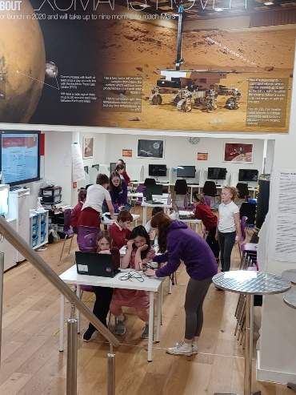
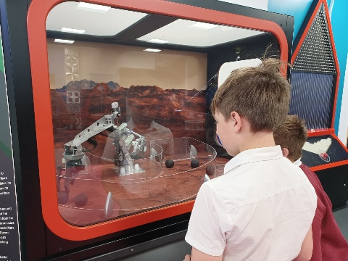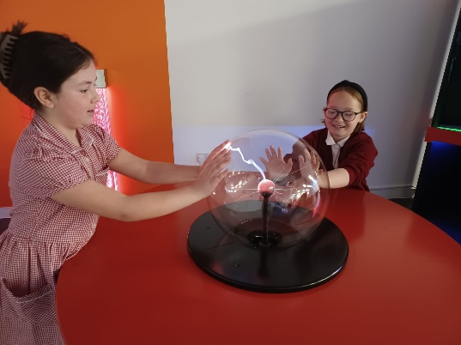
They programmed mini ‘Mars Rovers’ and had a great time in the science labs!

Covid UPDATE…
Government guidance remains that if someone knows that they have Covid then, out of consideration to others - as would be the case if they had flu, norovirus or any other unpleasant infectious disease - they should stay at home.
The government recommendation is to avoid contact with other people for at least 5 full days and then return to school once they feel better. The government particularly advises this for anyone with a temperature or cough.
Please continue to follow this guidance so we can look after everyone in our community.

General guidance around sickness and illness remains the same regardless of the illness, if a child or young person is unwell, they should not be attending nursery, school or college.
Similarly if we think that a child is unwell and needs to go home, we will continue to ask you in the same way.
You have been fantastically supportive throught this pandemic and I thank you again for all the efforts you have made to keep our school community safe.

HERTS INFORMATION ON COVID-19 vaccination

Vaccination continues to offer the best protection for ourselves and others around us from becoming seriously ill from COVID-19. There are lots of walk-in options available locally for first, second doses and boosters, you can find your nearest vaccination centre and also book an appointment at: https://covid.healthierfuture.org.uk/
The national booking system for healthy 5- to -11 year olds to receive their COVID-19 vaccination will open from 2 April. Parents and carers can book appointments at larger vaccination centres and in some community pharmacies. Appointments will also be available at some GP run sites, if so they will contact you directly and you can book through your practice.
Vaccinations are already available for clinically vulnerable 5- to 11-year-olds, and children in this age group who live with someone who has a weakened immune system. Until now vaccinations for this ‘at risk’ group of children have been available through GPs and special schools, but parents and carers will also be able to book through these through the national booking service from 2 April.

For more information on vaccinations for this age group visit: https://covid.healthierfuture.org.uk/vaccine-information-for-young-people

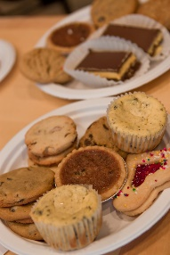
Events…
The FAS bake sale raised £144! Thank you so much for your cakes and purchases.
We have our Sports Day planned on 19th May and will send out more information nearer to the time.

We are also having a school Jubilee celebration, on 26th May in the afternoon. The Governors and FAS are arranging it, with entertainment, ice creams, and ‘bring your own’ picnics.

Phonics…
If your child is in EYFS/KS1 please look out for a letter next week regarding the new phonics scheme and the books your children will be bringing home.

Rota & curriculum…

The next two weeks are as follows:
Week A – 25th – 29th April
Tuesday – MUSIC – NORMAL UNIFORM |  | Thursday – PE – COME IN PE KIT
UKS2 (1 hr) | KS1 | LKS2 | UKS2

Week B – 3rd – 6th May
Tuesday – FOREST SCHOOL – OLDER CLOTHES |  | Thursday – PE - COME IN PE KIT
UKS2 (1hr) | LKS2 | KS1 | EYFS

Finally…
We have been thinking about Easter in our Collective Worships this week, about the promise of new life and hope given to us. We have thought about the doubts of the disciples and how they felt. We have related this to our school value of hope and how we can support others in times of need and use our faith and belief to help us in tough times.

“Finally the other disciple, who had reached the tomb first, also went inside. He saw and believed.”
John 20:8

With kind regards
Mrs Connolly

Summer Term Dates

Bank Holiday Monday 2 May

SATS week 9 -12 May

Sports day Thursday 19 May

Last day of half term & Jubilee tea party Thursday 26 May

Extra Platinum Bank holiday day (in lieu) school closed. Friday 27 May

Return to school Monday 6 June

End of Summer Term Wednesday 20 July 2.30pm

The Term Dates for next year are now on the website.

