Ardeley St Lawrence C of E Primary School

Newsletter

21st October 2021
Dear Parents,
Good news…

Well done to these children for their hard work and fantastic attitudes:
RED: Isaac R, Ayva
ORANGE: Harley, Evie, Lillie-May
EYFS Star of the Week: Opie
Lunchtime Stars: Evie and Olivia

Harry received an Ardeley ambassador Values Band for Friendship as he has welcomed a new class member and has been very kind.

This has been a wonderful half term with exceptional behaviour and learning throughout the school. I am so proud of all of the children. They have deserved a rest!
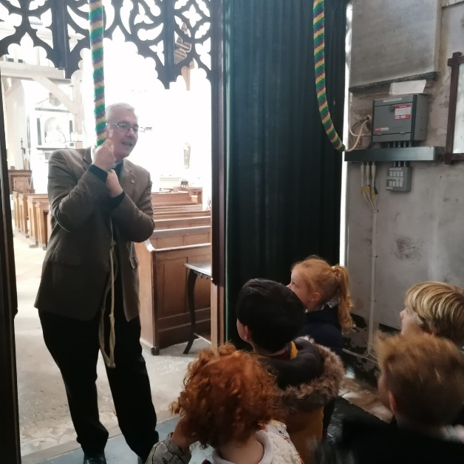
KS1 have been making bird feeders this week –it was a messy process!
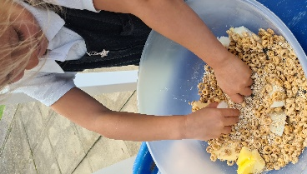

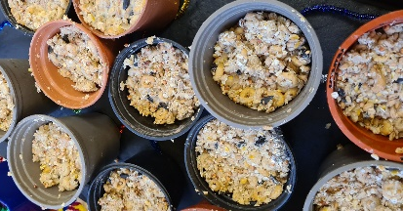
EYFS went to the church today to talk to Father Mark – we know they got to ring the bell because we could hear it from school!

Thank you for attending the parent consultations this week. It stayed dry although it was a little dark towards the end! This consultation was very much a ‘getting to know you’ and how your child is settling in. thank you for all your positive feedback – it was so lovely to be able to talk to you all.
Thank you also for following all the guidance, it is much appreciated.

Swimming for LKS2
Swimming starts after half term for LKS2 – please look out for the letter coming home about this TODAY. We are sorry for the short notice, getting the pool booked has been tricky but we are so pleased to be able to offer this again.

Cough, Cold, Covid?
If your child has a cough this is one of the main symptoms of Covid 19 – along with a temperature – so please do book them a PCR test and keep them at home until a negative result comes back.
We may ask you to take your child for a PCR tests if we notice they have a recurrant cough in school.

Thank you for continuing to support us in keeping school as safe as posssible. As the cold and flu season approaches, and with children (and adults) not having been exposed to the usual viruses for 18 months, we know it will be difficult to work out when it is OK to bring your child to school. If you have any doubt, we will support you if you wish to take your child for a PCR test and, if possible, keep them off school until the results are back. However, as a general guide, children can attend with “head colds” (bunged up/runny nose).
Thank you all for your understanding.
Open Morning…
Our Open Morning is on Monday 8 November, when the school will be open for any parents who may be thinking of sending their child to us in September 2022. You are welcome to look around for sibling admissions. Please spread the word – as always you are our best advert! The Open morning will run between 9.30 and 11.30am and our admissions arrangements are available on our school website. Please do spread the word to your friends and families. Your recommendations mean so much to us. Thank you.

Rota & curriculum…
ALL CHILDREN NEED WELLINGTON BOOTS AND A WATERPROOF JACKET IN SCHOOL PLEASE.
Please remember the children will be outside in virtually all weathers for PE & Forest School so layers are essential. Wellington boots and waterproof jackets can be left in school.

As we continue to keep the school well ventilated, and the temperature is dropping, please send in an extra layer/fleece that can be left here – this does not need to be in school colours.

The next two weeks are as follows:

Week A – 1st -5th November
Tuesday – Forest School Session |  | Thursday - PE
UKS2 (1 hr) | KS1 | LKS2 | UKS2

Week B – 8th – 12th November
Tuesday – Forest School Session |  | Thursday - PE
UKS2 (1 hr) | LKS2 | KS1 | EYFS

A reminder that all the information you may need is also on the website: https://www.ardeley.herts.sch.uk
Finally…
We talked in Collective Worship today about what a wonderful half term we have had with the children achieving so much and building every day on their strong foundations, which link back to our Christian values.
“For no one can lay any foundation other than the one already laid, which is Jesus Christ”
(1 Corinthians 3:11)

I do hope you all have a restful and enjoyable half term.

With kind regards
Mrs Connolly

PLEASE sign up to the school jotter app – this helps us reach you easily and quickly with reminders and sends the newsletter straight to your phone.

School Jotter:
Link to the app store - https://apple.co/2ITwmsm
Link to the android store -https://play.google.com/store/apps/details?id=com.webanywhere.schooljotter.containerApp

Autumn Diary Dates

INSET DAY (school closed to pupils) 22 October
Autumn Half Term 25 – 29 October

LKS2 Swimming Wednesday AM 3 November – 9 February

Flu vaccinations 5 November

Open Morning 8 November AM
School Disco 19 November
Wreath Making 29th November
Christmas Fair 3rd December
End of Autumn Term 2.30pm 17 December
INSET Days 20 & 21 December

Return to School 5 January 2022

Pantomime 6 January 2022

