Ardeley St Lawrence C of E Primary School

Newsletter

15th October 2021
Dear Parents,
Good news…

Well done to these children for their hard work and fantastic attitudes:
RED: Molly, Raphy, Ewan
ORANGE: Amelie, Laylah, Gethyn, Max, Bradley C, Indie, Annabelle
EYFS Star of the Week: Albie
Lunchtime Stars: Zach & Oscar

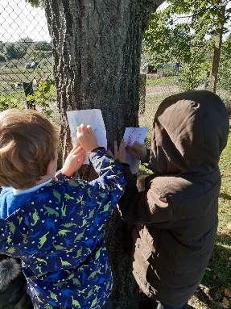
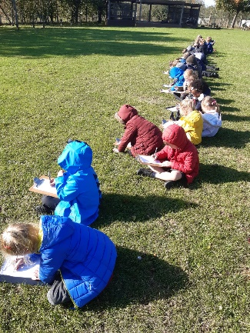
KS1 have been out and about,bird spotting, drawing trees and bark rubbing for their work on lines in Art.
UKS2 have had King Henry VIII in today! Thankfully all heads are still attached!
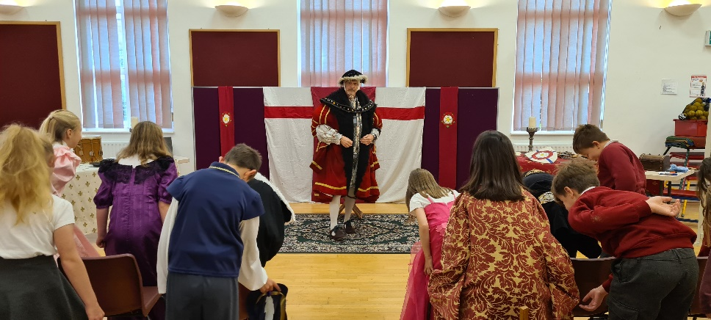

Parent Consultations
We are holding our parent consultations ‘in person’ next week; thank you for booking these via Wisepay.
In order to keep everyone as safe as possible the following systems will be in place, many of which are similar to the last parent consultations we held:
- Please arrive just in time for your appointment and come in through the back gate.
- Waiting for appointments will be outside so please do wrap up warm (I hope it is drier than last time!).
- Appointments will be in classrooms. These will have windows open and HEPA air filters running. Seating will be 2m apart.
- Appointments will be 10 minutes. I will ring the bell to keep to time.

As LKS2 parents will know, Miss Sheldon’s Parent Consultations have needed to be rescheduled. However all others, including consultations for siblings of children in Miss Sheldon’s class, will be continuing.

If you, or anyone in your household have ANY symptoms of Covid please do not attend your apppontment. We will be happy to rearrange or provide a telephone consultation.

Cough, Cold, Covid?
Thank you for continuing to support us in keeping school as safe as posssible. As the cold and flu season approaches, and with children (and adults) not having been exposed to the usual viruses for 18 months, we know it will be difficult to work out when it is OK to bring your child to school. If you have any doubt, we will support you if you wish to take your child for a PCR test and, if possible, keep them off school until the results are back. However, as a general guide, children can attend with “head colds” (bunged up/runny nose).
If your child has a cough this is one of the main symptoms of Covid 19 – along with a temperature – so please do book them a PCR test and keep them at home until a negative result comes back. Thank you all for your understanding.
Open Morning…
Our Open Morning is on Monday 8 November, when the school will be open for any parents who may be thinking of sending their child to us in September 2022. You are welcome to look around for sibling admissions. Please spread the word – as always you are our best advert! The Open morning will run between 9.30 and 11.30am and our admissions arrangements are available on our school website. Please do spread the word to your friends and families. Your recommendations mean so much to us. Thank you.

Rota & curriculum…
ALL CHILDREN NEED WELLINGTON BOOTS AND A WATERPROOF JACKET IN SCHOOL PLEASE.
Please remember the children will be outside in virtually all weathers for PE & Forest School so layers are essential. Wellington boots and waterproof jackets can be left in school.

As we continue to keep the school well ventilated, and the temperature is dropping, please send in an extra layer/fleece that can be left here – this does not need to be in school colours.

The next two weeks are as follows:

Week B – 18th – 21st October
Tuesday – Forest School Session |  | Thursday - PE
UKS2 (1 hr) | LKS2 | KS1 | EYFS

Week A – 1st -5th November
Tuesday – Forest School Session |  | Thursday - PE
UKS2 (1 hr) | KS1 | LKS2 | UKS2

A reminder that all the information you may need is also on the website: https://www.ardeley.herts.sch.uk
Finally…
We talked in Collective Worship today about all the different families and groups we belong to. The children felt strongly that our school was like a family because we care for each other. We talked about how we are thought of as God’s children because he loves us and protects us.
“Be on your guard; stand firm in the faith; be courageous; be strong. Do everything in love.”
(1 Corinthians 16:13.14)

With kind regards
Mrs Connolly

PLEASE sign up to the school jotter app – this helps us reach you easily and quickly with reminders and sends the newsletter straight to your phone.

School Jotter:
Link to the app store - https://apple.co/2ITwmsm
Link to the android store -https://play.google.com/store/apps/details?id=com.webanywhere.schooljotter.containerApp

Alternatively, you can just search for School Jotter in your phone store or use the QR codes below.

Autumn Diary Dates

School Photos Tuesday 19 October

Parent Consultations Tuesday 19 October
Parent Consultations Wednesday 20 October

INSET DAY (school closed to pupils) 22 October
Autumn Half Term 25 – 29 October

Flu vaccinations 5 November

End of Autumn Term 2.30pm 17 December
INSET Days 20 & 21 December

