Ardeley St Lawrence C of E Primary School

Newsletter

8th October 2021
Dear Parents,
Good news…

Well done to these children for their hard work and fantastic attitudes:
RED: Harper, Isla, Mason, Jack S
ORANGE: Ella B, Amber, Charlotte
EYFS Star of the Week: Azra
Lunchtime Stars: Mei and Bradley N

Updated Sponsored walk total… £1595!!!
Thank you for your generosity!
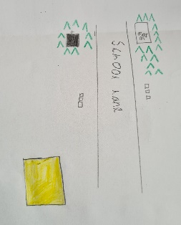

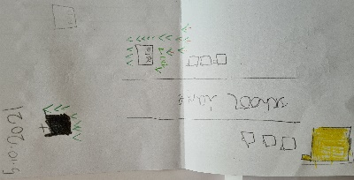
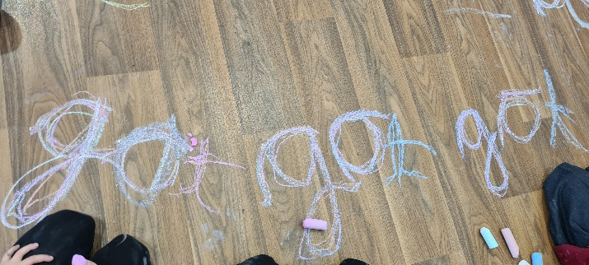
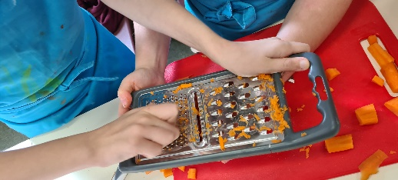
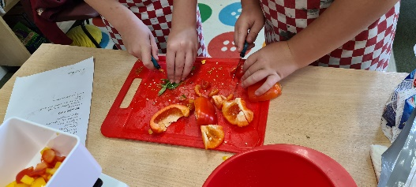

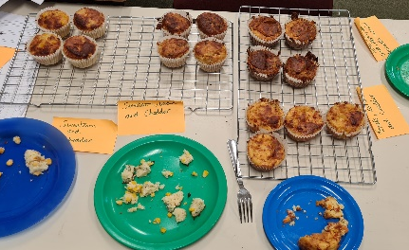

There has been lots going on around school as usual…UKS2 made savoury muffins, which Miss Mullins and I got to carry out a taste test on! KS1 walked along School Lane and then we used our knowledge of maps and symbols to make our own map of the area (the school is an important building in yellow). Reception have been practising their phonics and word building skills using chalks on the floor.

We have had a wonderful letter of thanks for the donations to The Haven – they are so appreciative of your support.

Our new school council met for the first time this week – things they have raised include more non uniform days, slower driving on School Lane and more singing in the church.
Cough, Cold, Covid?
Thank you for continuing to support us in keeping school as safe as posssible. As the cold and flu season approaches, and with children (and adults) not having been exposed to the usual viruses for 18 months, we know it will be difficult to work out when it is OK to bring your child to school. If you have any doubt, we will support you if you wish to take your child for a PCR test and, if possible, keep them off school until the results are back. However, as a general guide, children can attend with “head colds” (bunged up/runny nose).
If your child has a cough this is one of the main symptoms of Covid 19 – along with a temperature – so please do book them a PCR test and keep them at home until a negative result comes back. Thank you all for your understanding.
Funding…
Thank you so much for our support with our Census day lunch – nearly everyone had a school dinner.
Parking at the end of the day…
Please do not block drives, or paths, or park on the yellow chevrons outside the school. Remember, drop off runs for 15 minutes (3.15 to 3.30pm) so there is time for a few ‘swap overs’ of spaces. We need to be safe for all the children.

Church Service…
Revd Mark will be taking the communion service in Ardeley St Lawrence church, this Sunday at 9.30am. We also have ‘Little Fishes’ (Junior Church) meeting in the village hall from 9.20am. Little Fishes is for all children from toddlers upwards. It is a way to learn about Jesus through play, laughter and being with others. Please do come along, refreshments are available after church.

Rota & curriculum…
ALL CHILDREN NEED WELLINGTON BOOTS AND A WATERPROOF JACKET IN SCHOOL PLEASE.
Please remember the children will be outside in virtually all weathers for PE & Forest School so layers are essential. Wellington boots and waterproof jackets can be left in school.
As we continue to keep the school well ventilated, and the temperature is dropping, please send in an extra layer/fleece that can be left here – this does not need to be in school colours.

The next two weeks are as follows:

Week A – 11th – 15th October
Tuesday – Forest School Session |  | Thursday - PE
UKS2 (1 hr) | KS1 | LKS2 | UKS2

Week B – 18th – 21st October
Tuesday – Forest School Session |  | Thursday - PE
UKS2 (1 hr) | LKS2 | KS1 | EYFS

A reminder that all the information you may need is also on the website: https://www.ardeley.herts.sch.uk
Finally…
We talked in Collective Worship today about different ways in which people all over the world worship God and pray to him. We talked about how our Merit Certificates show how we follow God, following his teaching in how we work and play; looking after each other, tidying away, caring for others and working hard. So whether you eat or drink or whatever you do, do it all for the glory of God (1 Corinthians 10:31)

With kind regards
Mrs Connolly

PLEASE sign up to the school jotter app – this helps us reach you easily and quickly with reminders and sends the newsletter straight to your phone.

School Jotter:
Link to the app store - https://apple.co/2ITwmsm
Link to the android store -https://play.google.com/store/apps/details?id=com.webanywhere.schooljotter.containerApp

Alternatively, you can just search for School Jotter in your phone store or use the QR codes below.

Autumn Diary Dates

Living History session UKS2 Friday 15 October

School Photos Tuesday 19 October

Parent Consultations Tuesday 19 October
Parent Consultations Wednesday 20 October

INSET DAY (school closed to pupils) 22 October
Autumn Half Term 25 – 29 October

Flu vaccinations 5 November

End of Autumn Term 2.30pm 17 December
INSET Days 20 & 21 December

