Ardeley St Lawrence C of E Primary School

Newsletter

1st October 2021
Dear Parents,
Good news…

Well done to these children who have made a wonderful start to the year and have earnt their first merit certificate:
RED: Chloe, Eliza, Leon, Amelie, Poppy, Theo, George, Felix, Gabriel, Grace, Dougie, Olivia, Ella L, Milo, Lyra-Rae, Rohan, Sophia, Abigail, Noah, Leo, Rocco, Isaac, Bradley L,
EYFS Star of the Week: Oscar
Lunchtime Stars: Opie, Dougie, Lyra-Rae, Ayva

What a wonderful week! Despite the rain we managed to complete 2 sponsored walks and even stay mostly dry (although quite muddy!). The children and adults all had a great time. My thanks to Mrs Minson for organising it and all the helpers who came along too.
Thanks to your generosity we have raised £930!!! Thank you all so much. I have already ordered some new mobile speakers, as our old ‘Boom Box’ stopped working in the summer.
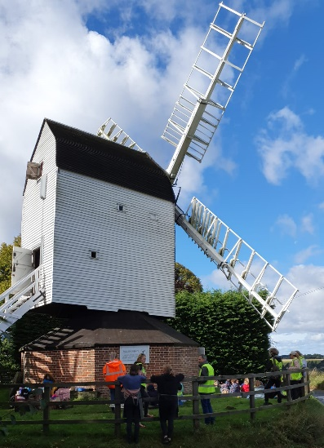
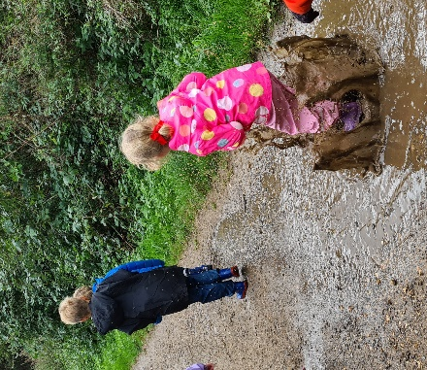

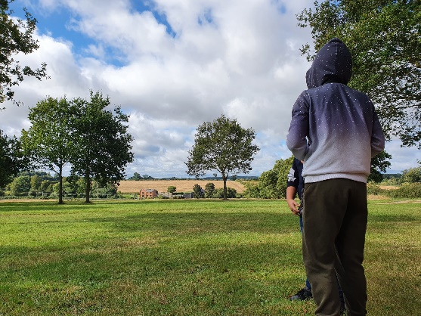

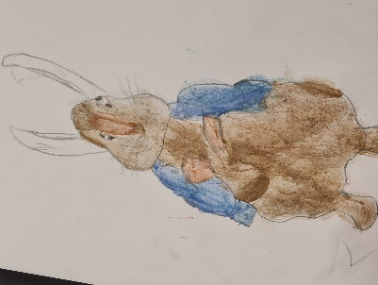
Year 5 & 6 welcomed visitors from Rural Care at Church Farm Ardeley to show them how to press apples and make apple juice this week.

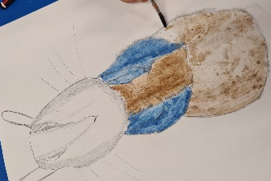
Year 3 & 4 have been doing some wonderful Beatrix Potter art, using water colours and pastels.

Thank you also for your generous donations for our Harvest Service. The children enjoyed being back in the church and we left many bags of food which was later taken to the Haven, the shelter in Stevenage.
Cough, Cold, Covid?
Thank you for continuing to support us in keeping school as safe as posssible. As the cold and flu season approaches, and with children (and adults) not having been exposed to the usual viruses for 18 months, we know it will be difficult to work out when it is OK to bring your child to school. If you have any doubt, we will support you if you wish to take your child for a PCR test and, if possible, keep them off school until the results are back. However, as a general guide, children can attend with “head colds” (bunged up/runny nose).
If your child has a cough this is one of the main symptoms of Covid 19 – along with a temperature – so please do book them a PCR test and keep them at home until a negative result comes back. Thank you all for your understanding.
Funding…
Thursday 7 October is our annual Census day. School dinners are counted on this day and also form part of our funding. In order to have as many children as possible having school dinners on this day we will be having a special census day menu of pizza & ice cream! Once again, please support us in ordering a school dinner for your child on this day.

Rota & curriculum…
ALL CHILDREN NEED WELLINGTON BOOTS AND A WATERPROOF JACKET IN SCHOOL PLEASE.
Please remember the children will be outside in virtually all weathers for PE & Forest School so layers are essential. Wellington boots and waterproof jackets can be left in school.
As we continue to keep the school well ventilated, and the temperature is dropping, please send in an extra layer/fleece that can be left here – this does not need to be in school colours.

The next two weeks are as follows:

Week B – 4th – 8th October
Tuesday – Forest School Session |  | Thursday - PE
UKS2 (1 hr) | LKS2 | KS1 | EYFS

Week A – 11th – 15th October
Tuesday – Forest School Session |  | Thursday - PE
UKS2 (1 hr) | KS1 | LKS2 | UKS2

A reminder that all the information you may need is also on the website: https://www.ardeley.herts.sch.uk

Finally…
We had our first whole school Collective Worship today in the hall (Co2 monitor on, windows open!) – it was another wonderful experience. The children were immaculately behaved and it was a pleasure to celebrate and pray together once again, remembering we are God’s family; When Jesus spoke to the people he said, “I am the light of the world. Whoever follows me will never walk in darkness but will have the light of life. (John 8:12)

With kind regards
Mrs Connolly

PLEASE sign up to the school jotter app – this helps us reach you easily and quickly with reminders and sends the newsletter straight to your phone.

School Jotter:
Link to the app store - https://apple.co/2ITwmsm
Link to the android store -https://play.google.com/store/apps/details?id=com.webanywhere.schooljotter.containerApp

Alternatively, you can just search for School Jotter in your phone store or use the QR codes below.

Autumn Diary Dates

Living History session UKS2 Friday 15 October

School Photos Tuesday 19 October

Parent Consultations Tuesday 19 October
Parent Consultations Wednesday 20 October

INSET DAY 22 October
Autumn Half Term 25 – 29 October

Flu vaccinations 5 November

End of Autumn Term 2.30pm 17 December
INSET Days 20 & 21 December

