Ardeley St Lawrence C of E Primary School

Newsletter

5th March 2020
Dear Parents
Good news…
We are so excited to welcome all the children back to school on Monday! Thank you for the immense job you have done at home, supporting your children through everything. Thank you for helping children with the technology and online calls and learning…goodness what we have all learnt!

Staff have chosen a ‘Star of the Week’ each, recognising the immense effort being put in by the children at home and at school; we are so proud of you! Miss Mullins will email you a certificate you can print out and fill in.
This week’s stars are: Mason, Brody, Harry, Laylah and Stan G, and I explain why in my recorded assembly.
Back to school systems…
Please make sure that you have read the return to school information which is on the website (Parents tab, Covid 19 – information for parents) and which has been emailed to you. This includes details on drop off, collection and uniform. Also on the website is our Risk Assessment, which again details all the ways in which we keep the school as safe as possible.
Children are welcome to bring in their work that they have completed at home. Staff will not mark it, but will look through this work to aid their assessment and planning. If your child has borrowed a device, please return it on Monday – thank you.

Testing and symptoms…
Staff are continuing the twice weekly ‘Lateral Flow Test’, carried out at home. If a test returns positive, we will then track close contacts and close a bubble as before.
Households with primary school, secondary school and college age children, including childcare and support bubbles, can test themselves twice every week at home as schools return from Monday 8 March. These tests are NOT given out by the school or administered by us; however you will need to let us know immediately please if anyone in the household/bubble has a positive result. The twice-weekly test kits can be accessed:
  - via employers if they offer testing to employees
  - at a local test site
  - by collecting a home test kit from a test site
  - by ordering a home test kit online
Currently these tests can be collected from the test site on Primett Road, in Stevenage; however this may change. You can order them online for home delivery from https://www.gov.uk/order-coronavirus-rapid-lateral-flow-tests
As before please DO NOT send your child to school if they or ANY member of your family have any of the symptoms of Coronavirus (temperature, cough, loss of taste/smell) and advise us immediately. Please also remember to inform us of any follow up positive test results (LFT or PCR). Please email covid@ardeley.herts.sch.uk or call the office.

Parent Consultations…
These were due to take place just before the Easter break. I will be moving these into the start of the Summer Term so that staff can talk to you about how the return to school has gone and assess the progress your children have made.
In school we will be avoiding terms like ‘catch up’, ‘lost learning’ and ‘fallen behind’. Our priority is to support your children coming back and to celebrate their achievements and their resilience. As always, wherever they are in their learning, we will support them to make further progress. Our Ardeley children are remarkable and have done their best in these challenging circumstances with your help and support.

Rota…
Please ensure that children have trainers that they can do up themselves for PE days please.
Children are often outside for an entire morning or afternoon – please ensure they now wear joggers rather than shorts on these days as the weather is still chilly! On forest school days, old clothes, lots of layers, waterproofs and wellingtons please!

Week A - 8 – 12 March
Tuesday – Forest School Session |  | Thursday - PE
UKS2 (1 hr) | KS1 | LKS2 | UKS2

Finally…
I was sent this prayer from the Diocese recently and I hope it resonates with you as it did for me:
Encompassing God, you are
Rest for the weary,
Strength for the weak,
Peace for the troubled,
Calm for the anxious,
Hope for the wanderer,
Love for the lonely,
Help for the sick,
Healing for the wounded,
Courage for the fearful,
Encompassing God, you are
With each of us now.
We ask you to bless Ardeley St Lawrence School
And enfold us in your love

With all my best wishes,
Mrs Connolly

VACANCY
at Ardeley St Lawrence Primary School & Nursery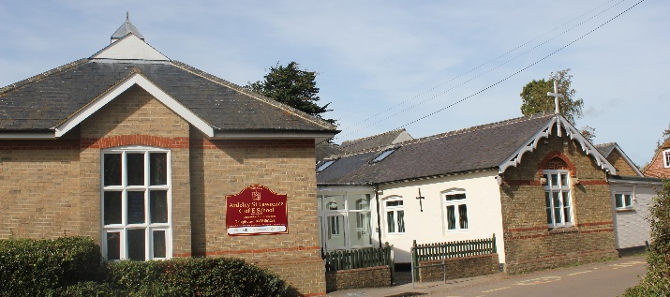
We are looking for a friendly and sociable
Midday Supervisor
We are looking for a person to look after our children while they eat and play at lunchtimes. You will be responsible for encouraging healthy eating and then running playground games.
The hours are 11.55am - 1.15 p.m.
Monday to Friday - Term Time only
Pay Scale £9.40 - £9.62 per hour
One term contract initially.
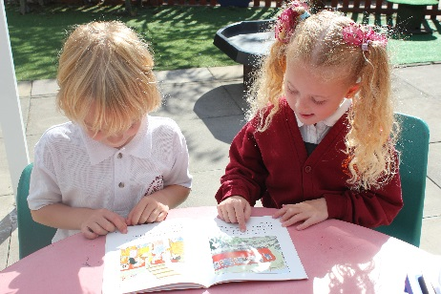
Please contact the school on 01438 861284 if you have any questions or for an application form.

