Ardeley St Lawrence C of E Primary School

Newsletter

11th December 2020
Dear Parents
Good news…
Well-deserved Merit Certificates this week go to:
ORANGE: Stan G, Woody, Henry, Sophia, Stanley, Tobie, Rocco, Daniel, Joshua, Cameron, Lenny, Amelie
YELLOW: Ewan, Evie
GREEN: Mei, Holly

We had some lovely snowman competition entries, some with lots of glitter, some 3D and with light up noses! It was so hard to choose but congratulations to our winners: Eliza, Rogue, Milo and Ewan.
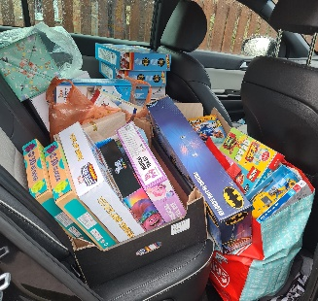
This afternoon I took our Toyshed donations over to the Foodshed. They were thrilled with the amazing donations you have given - that filled the back of my car. You are wonderful – thank you!
We understand that this may be a difficult time of year for some
of our families. If you are struggling yourself, please get
in touch with me, in confidence, to discuss support that may be available. You can also look on https://www.hertshelp.net/hertshelp.aspx

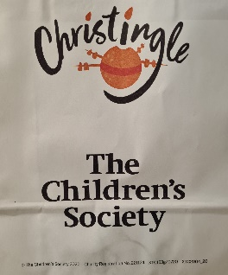
Each family have been given a Christingle bag to take home by the Little Fishes and Junior Church at Ardeley St Lawrence church. It would be lovely if these could be made on Sunday at 4pm and we can think about everyone who is joining with us to celebrate the Light of Christ.
Also in the bag is a leaflet with details of the Zoom Crib Service that the children can join on Christmas Eve.

As you know the School Council have been collecting crisp packets for some time now. We have donated these to a lady in Welwyn who is turning them into insulating blankets for homeless people; a wonderful, useful, recycle!
Events…
Christmas: The paper copy of our countdown for next week came home today.

Open Morning: A link is on the website to our ‘virtual’ Open Morning video. Because of the unique layout of Ardeley I am also able to do individual, outside only, tours. Please do spread the word if you know someone looking for a school place for September 2021; you are our best advert! Our Nursery admissions are also open – we deal with these ourselves, so please do call the office for an application form.

Covid…

If you are notified that you have been in contact with someone who has Covid, or anyone in your house has symptoms, please do call us or email us on covid@ardeley.herts.sch.uk before bringing your child to school. This includes siblings and parents.
We can then check with the local Public Health team and advise you on the next steps. This dedicated email address is checked out of hours, including weekends.

Please ensure you have read my recent email regarding the system for reporting positive cases up until Christmas Eve, and how we would notify you if your child needs to isolate. It is important that we notify anyone who may need to isolate, to protect anyone with vulnerable family. This letter is also on the website at https://www.ardeley.herts.sch.uk/parents-info/covid-19-information-for-parents

As you know we have to keep windows and doors open for more ventilation. As the temperature drops please do send in extra layers for your child – extra fleeces and jumpers like these do not have to be in school uniform colours (although children should still wear uniform underneath). We have invested in some air quality monitors which also help us to know when it is time to open all the windows and when we can close them!
MUD…
We have done so well being able to use the field for so long…but the mud today has finally defeated us. It was like the scene from the Vicar of Dibley out there today (if you remember that from all those years ago) with several children losing boots too!
For next week we will have the children on the playground, still in their bubbles and at different break times. At lunchtimes, one bubble is at play and the other is at the hall so they won’t be sharing the playground. Thank you for bearing with the mud and I’m sorry about all the washing.

Rota…
Please ensure that children have trainers that they can do up themselves for PE days please.
Children are often outside for an entire morning or afternoon – please ensure they now wear joggers rather than shorts on these days as the weather is definitely colder!

Week B – 14th – 18th December
Tuesday – Forest School Session | Thursday - PE
UKS2 (1 hr) ONLY | KS1 | EYFS

PLEASE sign up to the school jotter app – this helps us reach you easily and quickly with reminders and sends the newsletter straight to your phone.

School Jotter:
Link to the app store - https://apple.co/2ITwmsm
Link to the android store -https://play.google.com/store/apps/details?id=com.webanywhere.schooljotter.containerApp

Alternatively, you can just search for School Jotter in your phone store or use the QR codes below.

Finally thank you, once again, for your understanding, patience and kind words during our school lockdown. My thanks to the staff for the excellent home learning and to you all for helping your children at home.

Kind regards,

Mrs Connolly

Autumn Diary Dates

All events are subject to change in the event of a class/group needing to self isolate or if government guidance changes. We have worked very hard to try and ensure that some Christmas events can still go ahead. Obviously we have had to make changes to ensure these are in line with our current systems and following our recent closure. Please ensure you follow the details below. Thank you.

Monday 14 December FAS raffle draw
FAS raffle live on Facebook – look at their page for details.

Tuesday 15 December Class parties and give out cards
Children can bring in their OWN small party food ‘bag’ (crisps/cake/nothing refrigerated please, no nuts). In each class the children will have a ‘quiet’ party’ (with activities and allowed games). Please do NOT send in children in party clothes as it is too cold inside and out! Christmas cards will be given out today or tomorrow.

Wednesday 16 December FAS Gift Sale
Children who have pre-ordered with FAS will be collected by an adult from their bubble and taken to choose a gift.

Wednesday 16 December Christmas Lunch EYFS/KS1
EYFS/KS1 can wear a Christmas jumper (with the rest of their normal school uniform) and will eat Christmas dinner in the hall, served by staff from their bubble.
EYFS & KS1 Class movie afternoon – popcorn and squash provided by FAS (Free)
KS2 can only have home packed lunch today & will eat in classes (with their MSA).
Online Nativity Released (TBC)

Thursday 17 December Christmas Lunch KS2
KS2 can wear a Christmas jumper (with the rest of their normal school uniform) and will eat Christmas dinner in the hall, served by staff from their bubble.
KS2 - Class movie afternoon – popcorn and squash provided by FAS (Free)
EYFS/KS1 can only have home packed lunch today & will eat in classes (with their MSA).

Friday 18 December Panto
There will be 2 performances, one for each bubble.
School finishes at 2.30pm End of Term

