Ardeley St Lawrence C of E Primary School

Newsletter

20^{h} November 2020
Dear Parents
Good news…
A Merit Certificate this week goes to:
ORANGE: Jack C
Well done, you have made us very proud with your hard work and positive attitude.
Following on from Odd Socks Day on Monday, today’s assembly was about anti-bullying week and learning to value all the things that make us individual and special.

All your Bags2School donations have been collected, weighed and counted and you raised a wonderful £246! Thank you so much!

There have been some wonderful activities taking place around school…
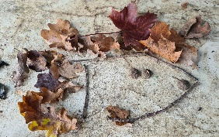
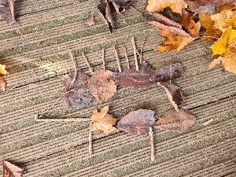
Key Stage One made woodland animals in Forest School.
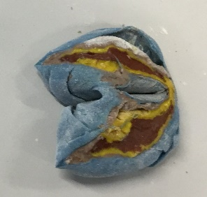

LKS2 used coloured playdough to build a model of the Earth. Each colour made a particular layer of the Earth's structure. When we cut them open, we could see the different layers.
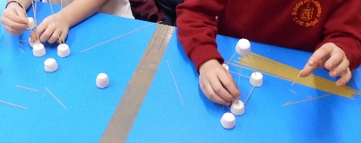
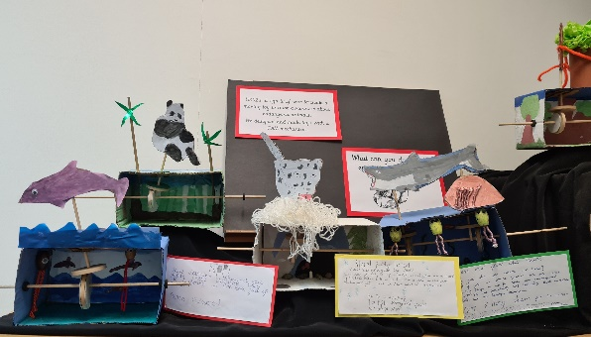

LKS2 also used marshmallows and spaghetti to make prototypes for earthquake resistant structures.

UKS2 have been making moving toys with a CAM mechanism.

Events…
Christmas: I have written a Christmas Countdown with details of all events and dates on – I know many of you found this useful last year. This will be sent out next week as a paper copy.

Open Morning: Our ‘virtual’ Open Morning video is ready – a link is on the website. My thanks to Mr Minson for putting it all together and to all the parents who have let us film their children. Because of the unique layout of Ardeley I am also able to do individual, outside only, tours. Please do spread the word if you know someone looking for a school place for September 2021; you are our best advert!
Covid…
If you are notified that you have been in contact with someone who has Covid, or anyone in your house has symptoms, please do call us or email us on covid@ardeley.herts.sch.uk before bringing your child to school. This includes siblings.
We can then check with the local Public Health team and advise you on the next steps. This dedicated email address is checked out of hours, including weekends. We have been asked by County to remind everyone of the self-isolation requirements which include not letting siblings who are self-isolating come on the school run or collect children: http://www.hertfordshire.gov.uk/selfisolatingguide
Our thanks to everyone so far who have been really helpful and sensible when required.

As you know we have to keep windows and doors open for more ventilation. As the temperature drops please do send in extra layers for your child – extra fleeces and jumpers like these do not have to be in school uniform colours (although children should still wear uniform underneath).
We have invested in some air quality monitors which also help us to know when it is time to open all the windows and when we can close them!
Looking after each other…
Thank you to all parents who have been wearing masks on site when collecting the children at the end of the day; it helps us to keep everyone as safe as possible.

This year we have decided to join the Toyshed appeal, run by the Foodshed, to give vulnerable families and children presents at Christmas. The idea is that as many members as possible of our school community (parents, staff and governors) buy and donate a BRAND NEW toy for around £10. The Toyshed will then give them to struggling parents to give to their children on Christmas day.
The present can be for an older boy or girl or a younger boy or girl and does not need to be wrapped. Please no used or second hand toys. These donations need to be delivered by the start of December so, should you wish to donate a toy, please send it in by Friday 4 December.
We understand that this may be a difficult time of year for some of our families and we only ask for a donation if you feel you are able to help. If you are struggling yourself please get in touch with me, in confidence, to discuss support that may be available.

Rota…
Please ensure that children have trainers that they can do up themselves for PE days please.
Children are often outside for an entire morning or afternoon – please ensure they now wear joggers rather than shorts as the weather is definitely colder!

Week A – 23rd – 27th November
Tuesday – Forest School Session |  | Thursday - PE
UKS2 (1 hr) | KS1 | LKS2 | UKS2

Week B – 30th November – 4th December
Tuesday – Forest School Session |  | Thursday - PE
UKS2 (1 hr) | LKS2 | KS1 | EYFS

PLEASE sign up to the school jotter app – this helps us reach you easily and quickly with reminders and sends the newsletter straight to your phone.

School Jotter:
Link to the app store - https://apple.co/2ITwmsm
Link to the android store -https://play.google.com/store/apps/details?id=com.webanywhere.schooljotter.containerApp

Alternatively, you can just search for School Jotter in your phone store or use the QR codes below.

Kind regards,

Mrs Connolly

Autumn Diary Dates

Friday 4 December Last day to hand in a Toyshed present donation

Saturday 5 /Sunday 6 December Volunteers to help with the collection of wreath greenery. Time TBC
Monday 7 December Wreath making evening (8:00 - 9:30pm) Ring Central (Zoom) event
Wednesday 9 December Class Movie & Father Christmas (3:20 – 5:30pm). The movie event is free. Tickets to be booked for Father Christmas via FAS.

Friday 11 December FAS Gift Sale

Wednesday 16 December Christmas Lunch EYFS & KS1 (KS2 – home packed lunch)
Raffle prize draw at school (3:15pm).

Thursday 17 December Christmas Lunch KS2 (EYFFS & KS1 Home packed lunch)

Friday 18 December In-school Panto
End of term - 2.30pm

