Ardeley St Lawrence C of E Primary School

Newsletter

25th September 2020
Dear Parents
Good news…
Well done to these children who have made a wonderful start to the year and have earnt their first merit certificate:
RED: Ewan, Lacey, Owen, Evie, Harley, Ayva, Laylah, Amber, Cameron.

Rain…and Covid
Sadly, I think the last of the good weather has left us!
When it is raining at collection time please still stagger your arrival. A smaller number of parents arriving at a time means we can get the children out to you more quickly.

At school we are keeping windows and doors, open as recommended, for extra ventilation. As the weather has started to get cooler please consider sending children in a vest or with an extra layer they can put on.

Thank you for using all of the time during drop off. This keeps the traffic flowing and ensures the system can work. This week’s ‘Drop Off, Dress Up’s theme was Cowboys! Thanks to Mrs Sendall for joining in this week (although as she normally takes the photo there is no evidence this week!)

As you know, this week, the government have further tightened the restrictions to try and stem the rising tide of infections. Please help us to keep the whole community safe by staying 2m apart when collecting children on the playground and not gathering in groups outside the school gates.
If your child has a persistent new cough, a temperature or has lost sense of taste and smell please do not bring them to school. Children without these symptoms but with a cold (runny nose) can still come to school.
Forms and Funding…
Please return data collection forms have been sent out. Please ensure we have up to date contact numbers for you and at least one other emergency contact should we not be able to reach you.

Please do also register for the Universal or Free School Meals. I cannot stress highly enough the difference this additional funding makes to the children. If you have not yet registered it is quick and easy and it may be worth checking if your circumstances have changed since last year. Just go to: www.hertfordshire.gov.uk/freeschoolmeals

Forest Schools & PE…
As the weather changes layers will be essential, as the children will be outside in all weathers. Wellington boots and waterproof jackets can be left in school.

The next two weeks are as follows:
Week B – 28th September – 2nd October
Tuesday – Forest School Session |  | Thursday - PE
UKS2 (1 hr) | LKS2 | KS1 | EYFS

Week A – 5th – 9th October
Tuesday – Forest School Session |  | Thursday - PE
UKS2 (1 hr) | KS1 | LKS2 | UKS2
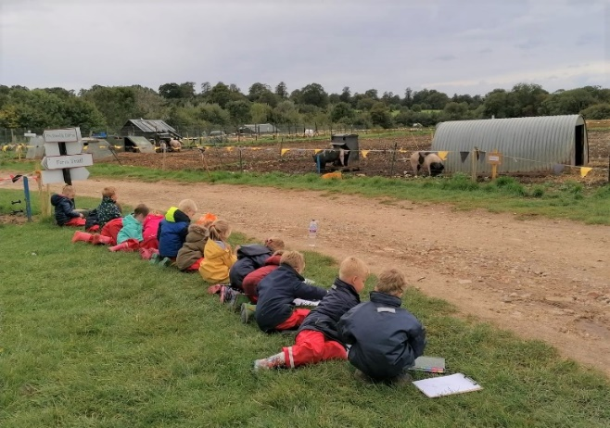

EYFS also made the most of the outside this week, visiting the farm to paint the pigs as part of their Beatrix Potter unit:

Lunches…
Next week EYFS/KS1 children will be able to order hot food and go to the village hall for lunch; KS2 will have packed lunches here.

We are running a simplified menu for the next 2 weeks:
MONDAY | TUESDAY | WEDNESDAY | THURSDAY | FRIDAY
FISH FINGERS, CHIPS AND VEGETABLES | BURGER IN BUN, WEDGES AND VEGETABLES | SAUSAGE, MASH AND BEANS | HOTDOG, PASTA AND VEGETABLES | CHEESE AND TOMATO PIZZA, CHIPS AND VEGETABLES
JACKET POTATO WITH CHEESE OR BEANS | JACKET POTATO WITH CHEESE OR BEANS | JACKET POTATO WITH CHEESE OR BEANS | JACKET POTATO WITH CHEESE OR BEANS | JACKET POTATO WITH CHEESE OR BEANS
CHEESE BAGUETTE | HAM BAGUETTE | CHICKEN BAGUETTE | HAM BAGUETTE | COLD PIZZA SLICE
SELECTION OF PUDDINGS | SELECTION OF PUDDINGS | SELECTION OF PUDDINGS | SELECTION OF PUDDINGS | SELECTION OF PUDDINGS

A cheese roll will also be available every day.
From 5 October we will be running 2 sittings as usual and all children can have a hot lunch.
Events…
Thank you for your generous donations for the Food Shed. They have asked me to pass on their thanks and appreciation. We had a wonderful outside Harvest service; the children heard the bible story about feeding the 5000 with the loaves and fishes. They all then went back in to have a (chocolate) fish & loaf and watch a short film of the bible story.
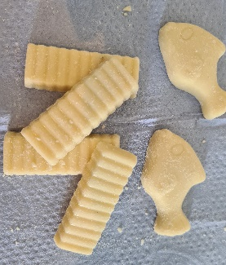
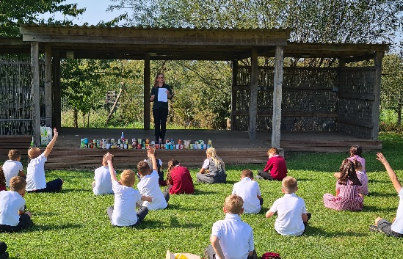
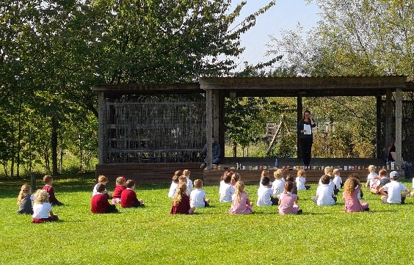

This is the final call to order the Virtual Summer Show, please order on Wisepay or contact the office. You will then receive a download code by email. Thank you for your support, every little bit of fundraising helps at the moment and I know it has been very well received by everyone who has watched it.

A reminder that all the information you may need is on the website: https://www.ardeley.herts.sch.uk/parents-info/covid-19-information-for-parents

With kind regards
Mrs Connolly
Autumn Diary Dates
To Be Confirmed (TBC)

Tuesday 6 October Celtic Harmony Trip – cancelled

Tuesday 20 October School Photos

Tuesday 20 October Parent Consultations - TBC
Wednesday 21 October Parent Consultations – TBC

Thursday 22nd October FAS Brownie cake sale (pre-ordered)

Friday 23 October INSET day

25 October – 30 October Half Term

