Ardeley St Lawrence C of E Primary School

Newsletter

18th September 2020
Dear Parents
Good news…
Well done to these children who have made a wonderful start to the year and have earnt their first merit certificate:
RED: Mei, Stan G, Holly
I would also like to mention the Year 2 children; they have impressed us all with how smoothly and sensibly they have adapted to being in a different ‘classroom’.

Staggered arrival and drop off…
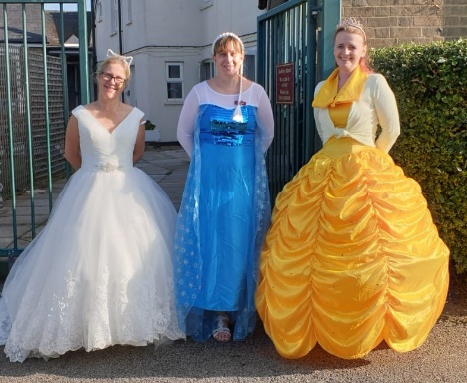
Thank you for using all of the time during drop off and pick up. This keeps the traffic flowing and ensures the system can work.
A reminder that the ‘queue’ for drop off should start no earlier than 8.40am. If you arrive earlier than this, please park up and wait as otherwise we block the road access for residents. Please don’t overtake when leaving the queue; it is a blind bend and we want to avoid any accidents.
This week’s ‘Drop Off, Dress Up’s theme was princesses!

The government have, this week, tightened the restrictions on groups of more than 6 people gathering. Please help us to keep the whole community safe by staying 2m apart when collecting children on the playground and not gathering in groups outside the school gates.

Forms and Funding…
Data collection forms have been sent out. Please ensure we have up to date contact numbers for you and at least one other emergency contact should we not be able to reach you.

Please do also register for the Universal or Free School Meals. I cannot stress highly enough the difference this additional funding makes to the children. If you have not yet registered it is quick and easy and it may be worth checking if your circumstances have changed since last year. Just go to: www.hertfordshire.gov.uk/freeschoolmeals

Covid information…

Thank you for completing our survey. I am pleased that everyone who responded felt that the online learning systems we had before worked well; this means we will use these again in the event of a bubble or school closure.
At school we are keeping windows and doors, open as recommended, for extra ventilation. As the weather gets cooler please consider sending children in a vest or with an extra layer they can put on. We have been lucky with the weather so far…long may it continue!

Forest Schools & PE…
As the weather changes layers will be essential, as the children will be outside in all weathers. Wellington boots and waterproof jackets can be left in school.

The next two weeks are as follows:
Week A – 21st -25th September
Tuesday – Forest School Session |  | Thursday - PE
UKS2 (1 hr) | KS1 | LKS2 | UKS2

Week B – 28th September – 2nd October
Tuesday – Forest School Session |  | Thursday - PE
UKS2 (1 hr) | LKS2 | KS1 | EYFS

Lunches…
Next week KS2 children will be able to order hot food and go to the village hall for lunch; KS1/EYFS will continue to have packed lunches here.
We are running a simplified menu for the next 2 weeks:
MONDAY | TUESDAY | WEDNESDAY | THURSDAY | FRIDAY
FISH FINGERS, CHIPS AND VEGETABLES | BURGER IN BUN, WEDGES AND VEGETABLES | SAUSAGE, MASH AND BEANS | HOTDOG, PASTA AND VEGETABLES | CHEESE AND TOMATO PIZZA, CHIPS AND VEGETABLES
JACKET POTATO WITH CHEESE OR BEANS | JACKET POTATO WITH CHEESE OR BEANS | JACKET POTATO WITH CHEESE OR BEANS | JACKET POTATO WITH CHEESE OR BEANS | JACKET POTATO WITH CHEESE OR BEANS
CHEESE BAGUETTE | HAM BAGUETTE | CHICKEN BAGUETTE | HAM BAGUETTE | TUNA BAGUETTE
SELECTION OF PUDDINGS | SELECTION OF PUDDINGS | SELECTION OF PUDDINGS | SELECTION OF PUDDINGS | SELECTION OF PUDDINGS

A cheese roll will also be available every day.

Events…
On Monday we have our Harvest Service which will be held outside. Unfortunately, no parents can attend. Please send in donations of tins and packets – no fresh food please.
Your donations will be hugely appreciated by the Food Shed.

If you wish to order the Virtual Summer Show, please order on Wisepay or contact the office. You will then receive a download code by email. Thank you for your support, every little bit of fundraising helps at the moment.

Unfortunately, we are unable to go to Celtic Harmony; the cost of the extra coaches to make the trip in our bubbles would be far too expensive and there may also be other schools on site.

A reminder that all the information you may need is on the website: https://www.ardeley.herts.sch.uk/parents-info/covid-19-information-for-parents

With kind regards
Mrs Connolly
Autumn Diary Dates
To Be Confirmed (TBC)

Monday 21 September Outside Harvest Service

Tuesday 6 October Celtic Harmony Trip – cancelled

Tuesday 20 October School Photos

Tuesday 20 October Parent Consultations - TBC

Wednesday 21 October Parent Consultations - TBC

Friday 23 October INSET day

25 October – 30 October Half Term

