Ardeley St Lawrence C of E Primary School

Newsletter

4th September 2020
Dear Parents
A great start…

It has been wonderful to have the children back in school this week…the school has been such a happy place. The children have been absolutely fantastic; they have settled straight back in and are so good at remembering how to keep as safe as possible!
Staggered arrival and drop off…
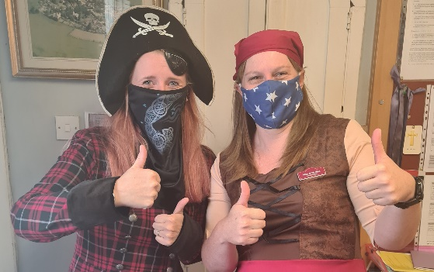
Thank you for using all of the time during drop off and pick up. This keeps the traffic flowing and ensures the system can work.
A reminder that the ‘queue’ for drop off should start no earlier than 8.40am. If you arrive earlier than this, please park up and wait as otherwise we block the road access for residents. Please don’t overtake when leaving the queue; it is a blind bend and we want to avoid any accidents.
This Friday saw the first of our ‘Drop Off, Dress Up’s; with Miss Mullins and I dressed as pirates. We thought this would add some fun to the Friday drop off – although we can’t promise a costume every week (especially when it is cold!)…

The government have, this week, tightened the restrictions on groups of more than 6 people gathering. Please help us to keep the whole community safe by staying 2m apart when collecting children on the playground and not gathering in groups outside the school gates.
Covid information…
We are approaching the ‘colds’ season..., in fact this week we have had a few children with very ‘bunged up’ noses! I know it is difficult to tell a ‘Covid cough’ from a normal cough so please do not bring your child in if they have a cough or any of the other Covid symptoms (high temperature, loss of taste or smell). Please ring your doctor or 111, and arrange a test.
I suspect that we may, at times, have to close a bubble when advised to do so by local Public Health Teams. We currently have a survey open to ask you about your preferred style of home learning if we have to do this: https://www.surveymonkey.co.uk/r/GGVN2BQ
At school we are keeping windows and doors, open as recommended, for extra ventilation. As the weather gets cooler please consider sending children in a vest or with an extra layer they can put on. We have been lucky with the weather so far…long may it continue!
Forms and Funding…
We will send out our various data collection forms soon. Please do ensure these are returned – we need to be able to contact you in the event of an emergency.
Please do also register for the Universal or Free School Meals. I cannot stress highly enough the difference this additional funding makes to the children. If you have not yet registered it is quick and easy and it may be worth checking if your circumstances have changed since last year. Just go to: www.hertfordshire.gov.uk/freeschoolmeals

Forest Schools…
Forest School sessions were a huge success this week.
Everyone also turned up on the right day in the right kit so well done to all of you organised parents at home!
As the weather changes layers will be essential, as the children will be outside in all weathers. Wellington boots and waterproof jackets can be left in school.

The next two weeks are as follows:
Week B – 14^{th –} 18th September
Tuesday – Forest School Session |  | Thursday - PE
UKS2 (1 hr) | LKS2 | KS1 | EYFS (tbc)

Week A – 21st -25th September
Tuesday – Forest School Session |  | Thursday - PE
UKS2 (1 hr) | KS1 | LKS2 | UKS2

Lunches…
Over the next week children will continue to have packed lunches from the special packed lunch menu I shared with you before the Summer Break.
On the week beginning the 21 September, KS2 children will be able to order hot food and go to the village hall for lunch; KS1/EYFS will continue to have packed lunches here.
The following week, beginning 28 September, KS1/EYFS will be able to order hot food and go to the village hall; KS2 will have packed lunches here.
I thought this would be easier than a day on/day off rota system which could be more confusing.
Then we hope, from the 5 October, all children will be able to go to the hall in their 2 sittings and have hot lunches, as the systems will have been tested and checked.

When sending in grapes for packed lunches please ensure these are cut lengthways; otherwise they can be a choking hazard.
We are a nut free school. We do have children with serious nut allergies and so there can be absolutely no products containing nuts brought in to school. Thank you for your cooperation.

Events…
Our first outside event with the children will be a Harvest Service. We can do this outside around the stage. Donations of tins and packets will be hugely appreciated by the Food Shed; where we can deliver donations in line with regulations.
We can also do ‘Bags to School’ this year – on Friday 13 November. More details to follow.

The Virtual Summer Show is finished; my thanks to Mr & Mrs Minson for the many hours of editing and compiling over the summer. We will be sending out ‘drop box’ links next week. If you haven’t ordered a copy and wish to do so, please order on Wisepay or contact the office. Thank you for your support.

We have finally had a refund from the insurance for the cancelled residential last year and will be sending out refunds, minus the non-refundable deposit, soon. We are still hoping to go to Celtic Harmony; we are just waiting on the latest information for schools after the changes this week by the government.

A reminder that all the information you may need is on the website: https://www.ardeley.herts.sch.uk/parents-info/covid-19-information-for-parents

With kind regards
Mrs Connolly
Autumn Diary Dates
To Be Confirmed (TBC)

Monday 21 September Outside Harvest Service

Tuesday 6 October Celtic Harmony Trip – TBC

Tuesday 20 October School Photos - TBC

Tuesday 20 October Parent Consultations - TBC

Wednesday 21 October Parent Consultations - TBC

Friday 23 October INSET day

25 October – 30 October Half Term

