Ardeley St Lawrence C of E Primary School

Newsletter

28 February 2020

Dear Parents,
Good news …
Well done to these children who were awarded their merit certificate this week. We are proud of them:
GREEN: Sophia, Eden, Rohan, Jasmine, Ella, Lilly, Rocco, Milo, Zach, Joshua B, Theo, Henry, Amelie, Lillie-May
BLUE: Joshua S
INDIGO: Saphi

EYFS made Elmer elephants before Half Term
and today learned about Ash Wednesday and Lent, including having ash crosses on their foreheads.
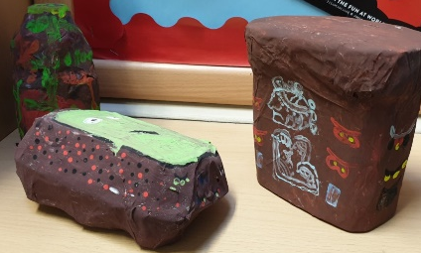

UKS2 have finished their Mayan instruments!
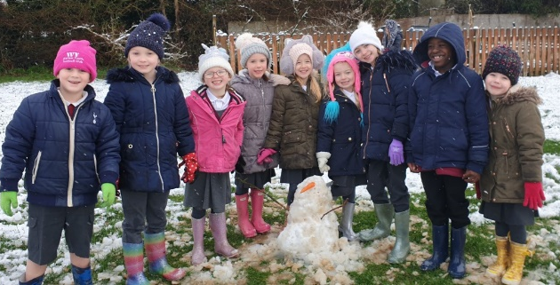

There was an unexpected flurry of snow this week – we made the most of it and snowmen rapidly appeared…and melted just as quickly.

We had our mid-year visit from our HIP (Hertfordshire Partner) just before half term. She complimented our work on Reading across the school saying, “Pupils were listened to read and the pupils were reading books appropriately pitched to their reading ability. This enabled them to read fluently and with good understanding. They were able to talk about the text, summarising key events, making predictions and discussing the meaning of vocabulary. Regular reading is promoted by all teachers.”
During the phonics teaching observed in Early Years and Key Stage 1, “Pupils were given opportunities to revise previous learning and apply new learning independently. Teachers ensured pupils understood the meaning of the words looked at and staff encouraged the correct pronunciation of the sounds studied. Pupils’ misconceptions were addressed well in a positive and encouraging manner, which helped to secure high levels of pupil participation.”
Well done everyone!

Germs & attendance…
We have all seen many national and local reports regarding the Coronavirus. As I mentioned earlier in the week we are following all Public Health England advice, which is updated regularly and sent to all schools. At the moment the advice is similar to the normal hygiene advice given during the annual flu season - washing hands regularly and ensuring sneezes are caught in tissues. We have information posters up in school and discussed this briefly in assembly today, looking at how to properly wash hands and not taking 5 paper towels to dry them!

Our attendance for last week was 95% - just a reminder please that if your child has a stomach bug, they must not return to school for 48 hours from the last bout of sickness - this is 2 school days. Whilst we appreciate your support on attendance this illness exclusion period is to stop sickness bugs spreading throughout the school.

Events and dates…
Parent Consultation slots will go live on Wisepay early next week.

World Book Day is next Thursday 5 March. This year we have decided on a theme which will hopefully take some of the ‘costume organising’ pressure away! Our theme will be bedtime stories – children can come in pyjamas/onesies and bring along their favourite bedtime story.

We have 2 Mother’s Day fundraising events happening with the help of FAS – our Gift Sale and our Mother’s Day Tea Party (with entertainment from the children). Details of these will come out in book bags.

Miss Mullins has managed to arrange some lamb feeding sessions for us this year after Easter; unfortunately, the farm can no longer offer us the sessions for free, however we have agreed a heavily discounted rate and so will only need to ask for a £1 donation per child. It is such a lovely opportunity for the children and we are lucky to be able to all go over and take part; permission slips will come out soon.

Letters regarding the Celtic Harmony Camp trip will come out next week.

Apology…date change
Due to unforeseen circumstances the Leavers’ Service this year has had to be moved to THURSDAY 16 July in the afternoon. Please accept my apologies.

Drop off system
Please can I ask you to switch off your car engines when waiting to drop off or collect your children. Leaving your engine idling causes air pollution which is very unhealthy for the children who walk past the cars. In addition, if you arrive before 8.40 am please park up and then join the drop off system when it starts moving at 8.45am. Creating a queue earlier than this does prevent local residents from getting out of their drives. Thank you for your cooperation.

Fundraising…
The FAS has joined AmazonSmile, the same Amazon you know. Same products, same prices, same service. Amazon donates 0.5% of the net purchase price of eligible purchases to the charitable organisation of your choice.
Please support your FAS! Simply do your usual amazon shop at smile.amazon.co.uk and choose Friends Of Ardeley School (capital for each word or it won’t find it).
Thank you!
Nursery applications open!
Our Nursery applications are open. Please do recommend us to your friends – we are always open for tours and enquiries. Application forms are on the website, or can be collected from the office, and applications are made directly to us (not through County).

With kind regards

Mrs Connolly

Spring Diary Dates

Monday 13 January – 30 March (11 weeks) Swimming Y3 & 4

Thursday 5 March World Book Day

Tuesday 10 March Parent Consultations
Wednesday 11 March Parent Consultations

Thursday 12 March FAS Mothers’ Day gift sale

Friday 20 March PM Mothers’ Day Tea Party

Wednesday 1 – Friday 3 April Residential

Thursday 2 April Celtic Harmony Trip

Friday 3 April 2.30pm End of Term

