Ardeley St Lawrence C of E Primary School

Newsletter

7 February 2020

Dear Parents,
Good news …
Well done to these children who were awarded their merit certificate this week. We are proud of them:
GREEN: Eve, Joshua, Stanley L, Jack, Tobie, Priya
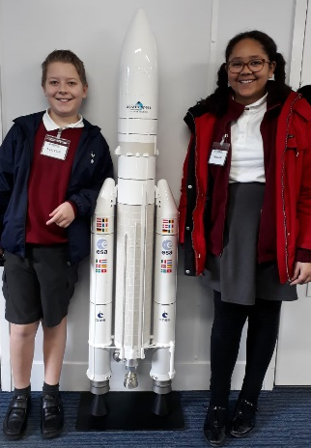
BLUE: Owen
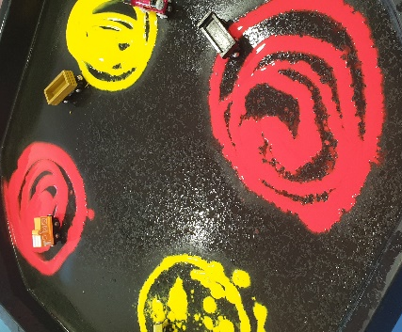
UKS2 went to Airbus this week as part of their work on Space! They had an amazing time.

EYFS have been working on colour and colour mixing this week –this is one of the activities BEFORE the children started!

Help needed!
An early request for donations of crème eggs please, for our Easter knitters! If you are also a keen knitter, then please let Mrs Jones know and she will set you up with a pattern.

Fundraising…
Thank you for your donations of cakes and for coming along to buy them. My thanks to FAS for organising the cake sale.
The FAS has joined AmazonSmile, the same Amazon you know. Same products, same prices, same service. Amazon donates 0.5% of the net purchase price of eligible purchases to the charitable organisation of your choice.
Please support your FAS! Simply do your usual amazon shop at smile.amazon.co.uk and choose Friends Of Ardeley School (capital for each word or it won’t find it).
Thank you!

Events and dates…
An early notification of a great social event – on Thursday 7 May we are having a VE Day Tea Party in the afternoon for everyone at school and our local community. We have booked a singing group already and are making other plans to make it a memorable and fun event!

Our new term dates are on the website. Please take advantage of the INSET day placements to avoid term time holidays and still benefit from cheaper travel. The Leavers’ Service this year will be on Friday 17 July in the afternoon.

Nursery applications open!
Our Nursery applications are open. Please do recommend us to your friends – we are always open for tours and enquiries. Application forms are on the website, or can be collected from the office, and applications are made directly to us (not through County).

With kind regards

Mrs Connolly
P.S Miss Honey has ‘found her bark’ as a few of you may have noticed at drop off! This is a normal part of dog development as she becomes a ‘teenager’(!!) and we are working on this during her training classes.

Please do ensure you have signed up for the links below so you can keep in touch.
School Jotter:
Link to the app store - https://apple.co/2ITwmsm
Link to the android store - https://bit.ly/2GRPx3U
Alternatively, you can just search for School Jotter in your phone store

Spring Diary Dates

Monday 13 January – 30 March (11 weeks) Swimming Y3 & 4

Monday 17 – Friday 21 February Half Term

Tuesday 10 March Parent Consultations
Wednesday 11 March Parent Consultations

Thursday 12 March FAS Mothers’ Day gift sale

Friday 20 March PM Mothers’ Day Tea Party

Wednesday 1 –Friday 3 April Residential

Friday 3 April 2.30pm End of Term

