Ardeley St Lawrence C of E Primary School

Newsletter

31 January 2020

Dear Parents,
Good news …
Well done to these children who were awarded their merit certificate this week. We are proud of them:
YELLOW: Felix, Hudson
GREEN: Chloe, Jack W, Jack S, Parker, Harry, Daniel, Harley, Holly, Oscar A
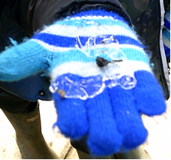
BLUE: Saphi, Taya

EYFS went on a senses walk – a very muddy senses walk – to the farm.
KS1 are learning about seasons – they went on a Winter Walk.
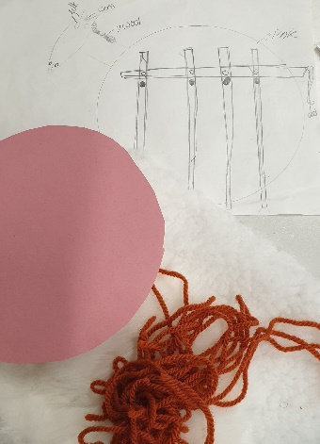

LKS2 are making animals using levers in Design and Technology. They are choosing the materials to complete their design.
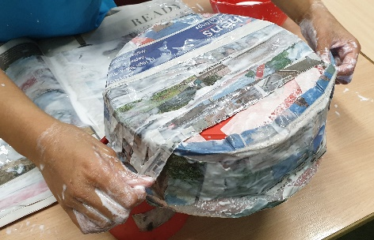
UKS2 used Paper Mache to build their Mayan instruments (and make a great big mess!).

Help needed!
An early request for donations of crème eggs please, for our Easter knitters! If you are also a keen knitter, then please let Mrs Jones know and she will set you up with a pattern.

Events and dates…
Next Friday – 7 February – the FAS are having a cake sale after school (3pm onwards). Please bring in your donations of cakes to the office that morning.

An early notification of a great social event – on Thursday 7 May we are having a VE Day Tea Party in the afternoon for everyone at school and our local community. We have booked a singing group already and are making other plans to make it a memorable and fun event!

Our new term dates are on the website. Please take advantage of the INSET day placements to avoid term time holidays and still benefit from cheaper travel. The Leavers’ Service this year will be on Friday 17 July in the afternoon.

Nursery applications open!
Our Nursery applications are open. Please do recommend us to your friends – we are always open for tours and enquiries. Application forms are on the website, or can be collected from the office, and applications are made directly to us (not through County).

With kind regards

Mrs Connolly

Please do ensure you have signed up for the links below so you can keep in touch.
School Jotter:
Link to the app store - https://apple.co/2ITwmsm
Link to the android store - https://bit.ly/2GRPx3U
Alternatively, you can just search for School Jotter in your phone store

Spring Diary Dates

Monday 13 January – 30 March (11 weeks) Swimming Y3 & 4

Friday 7 February FAS cake sale

Monday 17 – Friday 21 February Half Term

Tuesday 10 March Parent Consultations
Wednesday 11 March Parent Consultations

Thursday 12 March FAS Mothers’ Day gift sale

Friday 20 March PM Mothers’ Day Tea Party

Wednesday 1 –Friday 3 April Residential

Friday 3 April 2.30pm End of Term

