Ardeley St Lawrence C of E Primary School

Newsletter

24 January 2020

Dear Parents,
Good news …
Well done to these children who were awarded their merit certificate this week. We are proud of them:
RED: Eliza
YELLOW: Leon, Harper
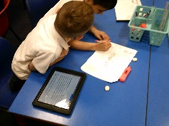
This week KS1 have been using technology to research. After learning about how to access the internet on a tablet, we discussed key words that will help our search. We can now find images, videos and facts about a topic!

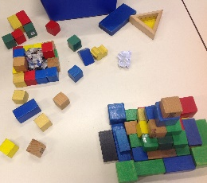
UKS2 constructed Mayan temples after learning about the techniques that the Mayans used.
LKS2 have been making volcanoes in Science using chemical reactions.

Thank you!
Thank you for all the fundraising you have been doing. We have bought some fantastic topic books to support our learning and develop our library.
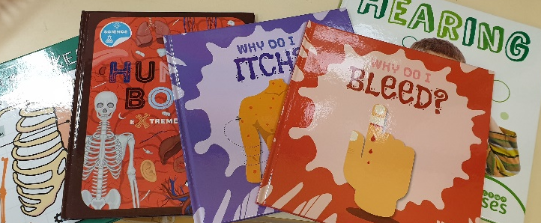

Help needed!
We desperately need help for the morning drop off system! We have at least 2 days with no volunteers now. It takes just 15 minutes and helps everyone. Please consider volunteering – without your help this valuable service may have to stop running.

We also have a position available for a Midday Supervisory Assistant. This is for 1 hour a day and can be every day or for part of the week. Please pop into the office to find out more.

Events and dates…
An early notification of a great social event – on Thursday 7 May we are having a VE Day Tea Party in the afternoon for everyone at school and our local community. We have booked a singing group already and are making other plans to make it a memorable and fun event!

Our new term dates are on the website. Please take advantage of the INSET day placements to avoid term time holidays and still benefit from cheaper travel. The Leavers’ Service this year will be on Friday 17 July in the afternoon.

FAS have got some great fundraising events planned – on the 7 February they are having a cake sale, on 12 March the Mothers’ Day gift Sale and on 21 April ‘Bags 2 School’.

Nursery applications open!
Our Nursery applications are open. Please do recommend us to your friends. Application forms are on the website, or can be collected from the office, and applications are made directly to us (not through County).

With kind regards

Mrs Connolly

Please do ensure you have signed up for the links below so you can keep in touch.
School Jotter:
Link to the app store - https://apple.co/2ITwmsm
Link to the android store - https://bit.ly/2GRPx3U
Alternatively, you can just search for School Jotter in your phone store

Spring Diary Dates

Monday 13 January – 30 March (11 weeks) Swimming Y3 & 4

Friday 7 February FAS cake sale

Monday 17 – Friday 21 February Half Term

Tuesday 10 March Parent Consultations
Wednesday 11 March Parent Consultations

Thursday 12 March FAS Mothers’ Day gift sale

Friday 20 March PM Mothers’ Day Tea Party

Wednesday 1 –Friday 3 April Residential

Friday 3 April 2.30pm End of Term

