Ardeley St Lawrence C of E Primary School

Newsletter

17 January 2020

Dear Parents,
Good news …
Well done to these children who were awarded their merit certificate this week. We are proud of them:
YELLOW: Henry, Stan G, Joshua B, Stanley L, Cameron, Filip

Our LKS2 swimmers had a great first session this week; they behaved beautifully and all worked hard in the pool. Lots of them have told me how much they enjoyed it and they are looking forward to next week.
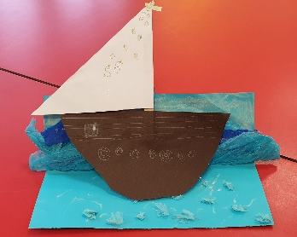
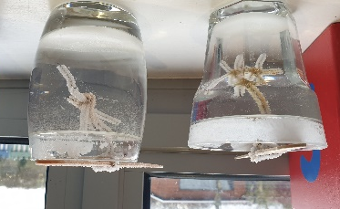
EYFS have been learning about penguins this week and have made ice crystals, KS1 have been working on their mixed media project – making boats to sit on their waves.

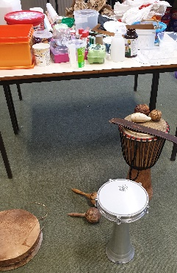
UKS2 are using a variety of recycled materials to make Mayan instruments.

Thank you!
Thank you for bearing with the mud! We are trying our best to balance the needs of the children to get out in the fresh air with keeping them dry & warm. The rain is not helping and everything is rather muddy, including Miss Honey who had to be washed 3 times in one day!

Help needed!
We desperately need help for the morning drop off system! We have at least 2 days with no volunteers now. It takes just 15 minutes and helps everyone. Please consider volunteering – without your help this valuable service may have to stop running.

We also have a position available for a Midday Supervisory Assistant. This is for 1 hour a day and can be every day or for part of the week. Please pop into the office to find out more.

Events and dates…
Our new term dates are on the website. Please take advantage of the INSET day placements to avoid term time holidays and still benefit from cheaper travel. The Leavers’ Service this year will be on Friday 17 July in the afternoon. This is a change from the date I published last week – when I was working a whole year ahead of myself!

Breakfast club has started and is already well attended. Bookings can be via WisePay or you can phone the office to book. Please remember all bookings must be received by 3pm the previous day.
FAS have got some great fundraising events planned – on the 7 February they are having a cake sale, on 12 March the Mothers’ Day gift Sale and on 21 April ‘Bags 2 School’.

Snow!
In the event of snow or other severe weather closing the school we will notify you in as many different ways as possible. Please follow this link to sign up for text messages from the County Closure system: https://member.everbridge.net/index/892807736725489#/login

Nursery applications open!
Our Nursery applications are open. Please do recommend us to your friends. Application forms are on the website and applications are made directly to us (not through County).

With kind regards

Mrs Connolly

Please do ensure you have signed up for the links below so you can keep in touch.
School Jotter:
Link to the app store - https://apple.co/2ITwmsm
Link to the android store - https://bit.ly/2GRPx3U
Alternatively, you can just search for School Jotter in your phone store

To join Twitter please search for @ardeleyschool and request to follow. We will then accept your request; if you have an unusual twitter name (that doesn’t include your surname) please let the office know as, for security, this is a ‘locked’ account and we only accept parents of children at the school as followers.
Spring Diary Dates

Monday 13 January – 30 March (11 weeks) Swimming Y3 & 4

Friday 7 February FAS cake sale

Monday 17 – Friday 21 February Half Term

Tuesday 10 March Parent Consultations
Wednesday 11 March Parent Consultations

Thursday 12 March FAS Mothers’ Day gift sale

Friday 20 March PM Mothers’ Day Tea Party

Wednesday 1 –Friday 3 April Residential

Friday 3 April 2.30pm End of Term

