Ardeley St Lawrence C of E Primary School

Newsletter

29th November 2019

Dear Parents,
Good news …
Well done to these children who were awarded their merit certificate this week. We are proud of them:
ORANGE: Blake, Rohan, Milo, Sophia, Leo, Lyra-Rae, Harrison, Abigail, Woody, Filip, Jack C, Harry Gr.
YELLOW: Joshua S, Oscar A, Mei, Harry Ge.

After School Club have been making Christmas
crafts – with these lovely snowmen made from
socks!

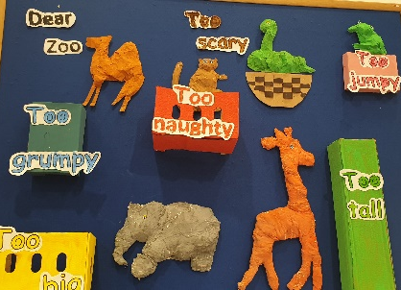
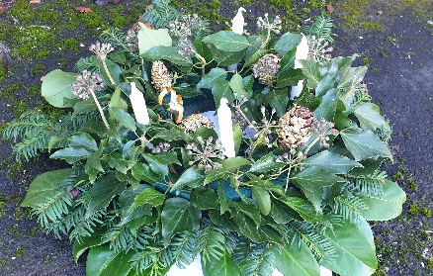
UKS2 have been making wreaths.

EYFS have been reading the book ‘Dear Zoo’ and made the animals from Modroc.

LKS2 have been planning their next science investigation into gases and KS1 have started their nativity practices! This year we have kept with a very traditional nativity with some minor audience participation (singing). I am looking forward to seeing it, as I am sure you are.

Help needed…
We need your help! We are short of volunteers for the Christmas fair. If you can help – even for an hour, please let anyone from FAS know or drop in to the office. This event is one of our biggest fundraisers of the year! Thank you.
Events and dates…
The lovely Christingle Service is on, this Sunday at 4pm at Ardeley Church. Please do come along, it is a lovely service for children.

Our Christmas Fair is on Friday 6 December from 3.30-6.30pm. We have a fabulous variety of external stalls, your children’s crafts on sale and Santa will be here too! Please spread the word and come along!

Please return FAS prize draw forms and money by 13th December. The draw will be picked on the 18th December at 3.15pm in the school hall and there are some wonderful prizes on offer.

On Sunday 8th December a group of our children are going to sing at the Ardeley Church ‘Celebration of music, songs and carols for Christmas’ service at 4pm. Do come along and support them, it is a lovely relaxed occasion; there are refreshments afterwards. A similar group of singers are also going to sing at the Lister Hospital on Monday 16th December in school time. I am sure they will make us proud and bring cheer to a lot of people.

Our Panto trip is in January and letters will be coming home soon with details. All classes (except Nursery) are going to see the pantomime this year on Thursday 9 January and FAS are kindly funding the tickets.
Snow!
In the event of snow or other severe weather closing the school we will notify you in as many different ways as possible. Please follow this link to sign up for text messages from the County Closure system:
https://member.everbridge.net/index/892807736725489#/login

Attendance…
Attendance last week was 96% - thank you.

Keeping in touch…
In book bags today is a Christmas Countdown detailing all the events between now and the end of term.
We try to keep you informed in as many different ways as possible;
We use WisePay for all messages and for payments and bookings.
We use Twitter for emergency messages, travel information and reminders.
We use School Jotter to send newsletters and reminders and emergency messages.
Please help us to help you and sign up so that you always know what is going on!

FAS would also like as many parents as possible to sign up to Classlist – an app which shares events with you. Please do sign up.

With kind regards

Mrs Connolly

Please do ensure you have signed up for the links below so you can keep in touch.
School Jotter:
Link to the app store - https://apple.co/2ITwmsm
Link to the android store - https://bit.ly/2GRPx3U
Alternatively, you can just search for School Jotter in your phone store

To join Twitter please search for @ardeleyschool and request to follow. We will then accept your request; if you have an unusual twitter name (that doesn’t include your surname) please let the office know as, for security, this is a ‘locked’ account and we only accept parents of children at the school as followers.
Autumn Diary Dates

Sunday 1 December 4.00pm Christingle

Friday 6 December 3.30-6.30pm Christmas Fair

Tuesday 10 December 2.00pm Nativity Matinee

Wednesday 11 December 1.30pm Children collected early
6.15pm Bring children to the church in costume/school uniform
6.30pm Nativity Evening Performance
*After school club will not run this evening*

12 & 13 December FAS Christmas gift Sale

Wednesday 18 December Christmas Lunch
3.15pm FAS prize draw in hall

Thursday 19 December Christmas parties

Friday 20 December 2.30pm End of Term
Spring Diary Dates

Monday 6 January INSET day – school closed to pupils
Tuesday 7 January School starts
Thursday 9 January Pantomime – Year R, 1, 2, 3, 4, 5, 6

