Ardeley St Lawrence C of E Primary School

Newsletter

22nd November 2019

Dear Parents,
Good news and thank you…
Well done to these children who were awarded their merit certificate this week. We are proud of them:
ORANGE: Leon, Felix, Hudson, Harry, Daniel, Eden, Ella, Maddie, Seffie, Jasmine, Tobie, Lenny, Molly, Holly, Joshua B, Cameron, Stanley L, Henry, Ayva, Priya
YELLOW: Eve, Saphi, Taya
GREEN: Owen, Lacey
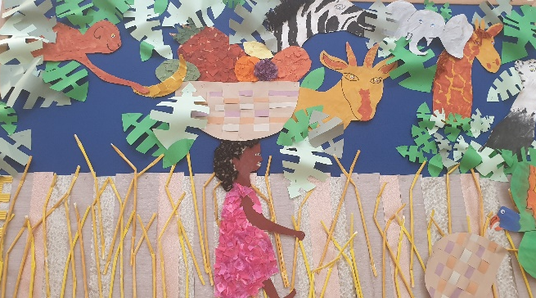
Early Years have been sharing the book Handa’s Surprise. They have tasted all of the fruits and have been learning the names of the animals.

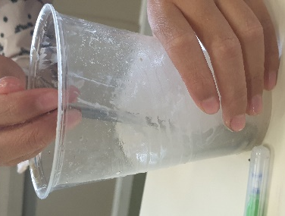
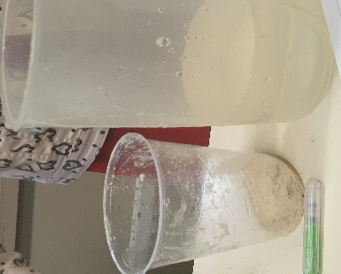

Year 5 & 6 have been investigating changing states in Science – in this experiment they
were looking at dissolving.

Ms Fry and Mrs Costa hosted an informal coffee morning today for parents of children with additional needs. Thank you to those who came along and, as you found it of value, we will host another one in the future. Any parent, or family member, who has a child with additional needs is very welcome to come along to the next coffee morning, on Friday 24 January 2020 at 9.15am, in the school hall.

After our excellent showing in the football tournament we are hoping to arrange some friendly matches in the New year with other small schools.

Father Mervyn took our Eucharist this week, in church, which was much appreciated.

Thank you to the parents who have come in to help with our Christmas craft days, your support was greatly appreciated.

Thank you for your wonderful donations today – the Tombola is going to be amazing!

Thank you also for your patience with the road closures – we had very little information or communication from the workmen to share with you and I know this would have been an extra stress on the school run.

Reminder…
No sweets as playtime snacks please – you are welcome to send in fruit (grapes need to be cut lengthways please).
The weather is much colder now – please send in named hats, gloves and scarves!

Events and dates…
Our Christmas Fair is on Friday 6 December from 3.30-6.30pm. We have a fabulous variety of external stalls, your children’s crafts on sale and Santa will be here too! Please spread the word!
Don’t forget to book your slot with SANTA – he is strictly ‘appointment only’!
Forms for this and the FAS Christmas Gift sale have been sent out – the deadline is NEXT FRIDAY 29th November.
Prize draw forms are going in book bags today - the draw will be picked on the 18th December at 3.15pm in the school hall.
Snow!
In the event of snow or other severe weather closing the school we will notify you in as many different ways as possible. Please follow this link to sign up for text messages from the County Closure system:
https://member.everbridge.net/index/892807736725489#/login

Attendance…
Attendance last week stayed at 97% - thank you.

Survey…
We thinking about starting a Breakfast Club and would like your opinion. We have an online survey https://www.surveymonkey.co.uk/r/QLCXG9D and have sent out a paper copy today (please only complete one version).

Keeping in touch…
We try to keep you informed in as many different ways as possible; however, many parents still haven’t signed up to WisePay, Twitter or School Jotter (see the link below). Please help us to help you!

With kind regards

Mrs Connolly

Please do ensure you have signed up for the links below so you can keep in touch.
School Jotter:
Link to the app store - https://apple.co/2ITwmsm
Link to the android store - https://bit.ly/2GRPx3U
Alternatively, you can just search for School Jotter in your phone store

Autumn Diary Dates

Monday 2 December 7pm FAS Wreath Making (£25)

Friday 6 December 3.30-6.30pm Christmas Fair

Tuesday 10 December 2.00pm Nativity Matinee

Wednesday 11 December 1.30pm Children collected early
6.15pm Bring children to the church in costume/school uniform
6.30pm Nativity Evening Performance
*After school club will not run this evening*

12 & 13 December FAS Christmas gift Sale

Wednesday 18 December Christmas Lunch
3.15pm FAS prize draw in hall

Thursday 19 December Christmas parties

Friday 20 December 2.30pm End of Term
Spring Diary Dates

Monday 6 January INSET day – school closed to pupils
Tuesday 7 January School starts
Thursday 9 January Pantomime – Year R, 1, 2, 3, 4, 5, 6

