Ardeley St Lawrence C of E Primary School

Newsletter

15th November 2019

Dear Parents,
Good news…
Well done to these children who were awarded their merit certificate this week. We are proud of them:
ORANGE: Lilly, Alex, Zach
A football team went out with Mr Moore today to compete in a ‘small schools’ football tournament. They made it all the way to the semi -finals! We are so proud of them – their behaviour and attitudes were absolutely fantastic. My thanks to Mr Moore for taking them.

Year 5/6 have started their Food Technology lessons looking at seasonal food, preparing it and cooking it.
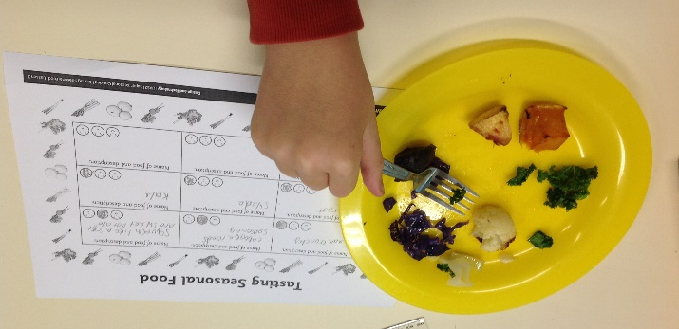

The rest of us today were dressed in spots and yellow to raise money for Children in Need. At the last count we had raised just over £75 which is fantastic. Thank you all for your support – in assembly this week I was explaining to the children the difference they can make to others, and this is a perfect example.

Also this week we held our ‘Odd socks day’ in support of Anti Bullying Week – celebrating all the things that make us unique.

KS1 enjoyed their Christmas Craft day this week – next Wednesday it is the turn of EYFS – please let the office know if you can come in and help.

Events and dates…
Our Christmas Fair is on Friday 6 December from 3.30-6.30pm. We have a variety of external stalls, your children’s crafts on sale and Santa will be here too! Please come along.
Forms for the FAS Christmas Gift sale and Father Christmas have been sent out – the deadline for this has been extended to 29th November. The FAS prize draw will be picked on the 18th November at 3.15pm in the school hall.

Next Friday (22nd November) is a non-uniform day – for a tombola donation. We would be delighted with a donation from the following:
Box of chocolates
Tin of biscuits
Toiletries or sets
Candles
Bottle of alcohol (please hand this directly to the school office)
Bottle of soft drink.

No tins please.

Thank you for your ongoing support.

Attendance…
Attendance last week was back up to 97%.

Website…
Our website has had a total refresh and is looking fantastic – with lots of lovely photos of the children. In the switch over some documents could not be transferred – this will be checked next week to ensure everything is up to date. Do have a look – it also works well on mobile phones now!

With kind regards

Mrs Connolly

Keeping in Touch…
Please do ensure you have signed up for the links below so you can keep in touch.
School Jotter:
Link to the app store - https://apple.co/2ITwmsm
Link to the android store - https://bit.ly/2GRPx3U
Alternatively, you can just search for School Jotter in your phone store.

Autumn Diary Dates

Wednesday 20 November EYFS Christmas craft day

Friday 22 November Non uniform day – for a tombola donation

Monday 2 December 7pm FAS Wreath Making (£25)

Friday 6 December 3.30-6.30pm Christmas Fair

Tuesday 10 December 2.00pm Nativity Matinee

Wednesday 11 December 1.30pm Children collected early
6.15pm Bring children to the church in costume/school uniform
6.30pm Nativity Evening Performance
*After school club will not run this evening*

12 & 13 December FAS Christmas gift Sale

Wednesday 18 December Christmas Lunch
3.15pm FAS prize draw in hall

Thursday 19 December Christmas parties

Friday 20 December 2.30pm End of Term
Spring Diary Dates

Monday 6 January INSET day – school closed to pupils
Tuesday 7 January School starts
Thursday 9 January Pantomime – Year R, 1, 2, 3, 4, 5, 6

