Ardeley St Lawrence C of E Primary School

Newsletter

8th November 2019

Dear Parents,
Good news…
Well done to these children who were awarded their merit certificate this week. We are proud of them:
ORANGE: Rocco, Jack B, Stan G, Lillie-may, Amelie, Noah, Ivy, Isla, Harper

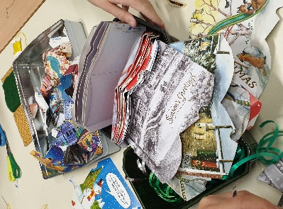
Christmas has started (sorry!) – with the first of the craft days for KS2. Over the following few weeks all the children will be making the different crafts and cards. My thanks to the parents who volunteer to help and to Mrs Jones who, over the year makes all the component parts of the cards. Mrs Jones tells me that it is all recycled and much of it is from cut offs that we throw away at school!
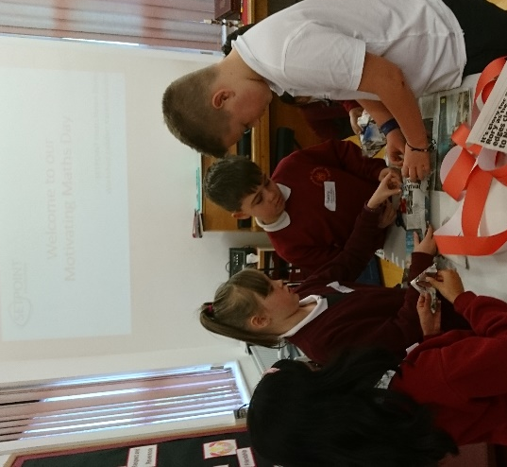

We hosted a Year 5 & 6 SETPOINT workshop called ‘Motivating Maths’.

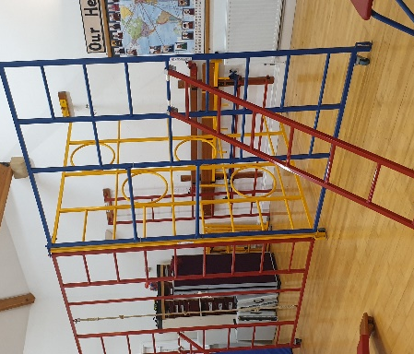
Mr Fitzgerald has started teaching gymnastics this term; we are so pleased to have a specialist teacher with the training to use all of our wonderful equipment!

We also made a Remembrance wreath. Year 6 accompanied me and laid this at the Village War memorial; we then observed a minute of silence.

Events and dates…
Next week we are having an ‘Odd socks day’ on Tuesday 12 November. The children are all invited to come to school wearing odd socks in support of Anti Bullying Week; this is an opportunity to encourage children to express themselves and celebrate their individuality and what makes us all unique!
Our Christmas Fair is on Friday 6 December from 3.30-6.30pm. We have a variety of external stalls, your children’s crafts on sale and Santa will be here too! Please come along.
Forms for the FAS Christmas Gift sale and Father Christmas will come out today and need to be returned by 18 November please.
We are sending out a paper copy of the dates for this term, as detailed at the end of this newsletter. We have started to use the ‘reminders’ on the School Jotter app and I hope you are finding these useful. Please continue to check our website, wisepay messages and tweets too.

Attendance…
Attendance in the week before half term dropped to 91% with illness affecting quite a few children. Our attendance officer has visited the school this week, she is concerned about the number of holidays being taken in term time. Please

Parking…
Parking at Ardeley has always been a difficult issue, and because of the nature of the village, it’s always going to be. I referenced a recent incident concerning parking on the chevrons in my last newsletter on 18.10.19 which I now realise was not as straight forward as it first appeared, and had a number of different sides to it. So, in view of this, I offer my apologies to the driver for the account of the incident. I would appeal to all our parents to foster tolerance and understanding in what are often difficult circumstances when trying to park.

Thank you…

Thank you for all of your Christmas card and photo orders.
Thank you also for spreading the word about our Open morning which was very successful. We had so many lovely compliments about the school and the beautiful behaviour of the children.

Residential…
Our residential is now confirmed for those children who have expressed an interest. Letters for deposit payments have come out this week. If your child would like to join the trip please ask the office for a letter.

With kind regards

Mrs Connolly

Keeping in Touch…
Please do ensure you have signed up for the links below so you can keep in touch.
School Jotter:
Link to the app store - https://apple.co/2ITwmsm
Link to the android store - https://bit.ly/2GRPx3U
Alternatively, you can just search for School Jotter in your phone store.

Autumn Diary Dates

Tuesday 12 November Odd Socks Day

Wednesday 13 November KS1 Christmas craft day
Wednesday 13 November 7.30pm FAS meeting – all welcome - speak to Selina or Katie for details.

Friday 15 November Small Schools’ Football Tournament
(1 x KS2 6 a side team + subs)

Friday 15 November Children in Need – wear something spotty or yellow for a donation

Wednesday 20 November EYFS Christmas craft day

Friday 22 November Non uniform day – for a tombola donation

Monday 2 December 7pm FAS Wreath Making (£25)

Friday 6 December 3.30-6.30pm Christmas Fair

Tuesday 10 December 2.00pm Nativity Matinee

Wednesday 11 December 1.30pm Children collected early
6.15pm Bring children to the church in costume/school uniform
6.30pm Nativity Evening Performance
*After school club will not run this evening*

12 & 13 December FAS Christmas gift Sale

Wednesday 18 December Christmas Lunch

Thursday 19 December Christmas parties

Friday 20 December 2.30pm End of Term
Spring Diary Dates

Monday 6 January INSET day – school closed to pupils
Tuesday 7 January School starts
Thursday 9 January Pantomime – Year R, 1, 2, 3, 4, 5, 6

