Ardeley St Lawrence C of E Primary School

Newsletter

24th October 2019

Dear Parents,
Good news…
Well done to these children who were awarded their merit certificate this week. They have all worked very hard:
ORANGE: Harry Ge, Oscar A, Taya, Ryelann, Harley, Oscar B, Dougie, Gabriel

Today we awarded our first ‘Ardeley Ambassador’ wrist bands of the year. These are awarded to children who consistently demonstrate our values and who are considered by all staff to be ambassadors for the school, as well as an excellent example to their peers. We are so proud of them!
They are:
KEY STAGE 1 VALUE
Lilly Love and Compassion
Maddie Respect

LOWER KEY STAGE 2 VALUE
Stan G Love and Compassion
Mei Respect
Eve Friendship

UPPER KEY STAGE 2 VALUE
Lacey Love and Compassion

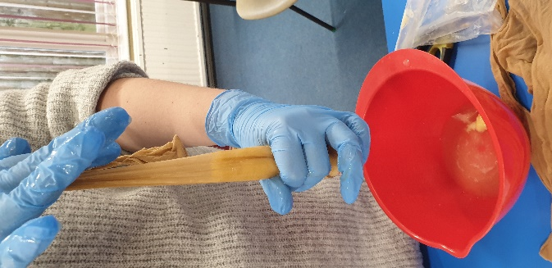
What a half term we have had! There have been so many exciting things going on in school. We have had trips to the farm, to Hatfield House, Tring museum and London. UKS2 have created sculptures with Mr Twiston-Davies, classes have baked biscuits for Design technology and there have been lots of pretty gruesome science experiments around school.
Today LKS2 have been learning about the digestive system….
and last week UKS2 made blood smoothies!
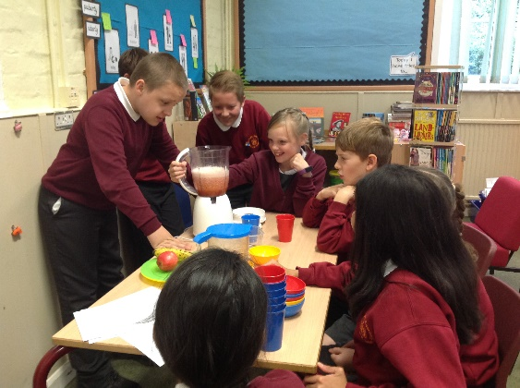

Events and dates…
Christmas cards are coming home today – please can orders be returned to school by Wednesday 6 November.
School photos are coming home today –please return by Tuesday 5 November.

Our Open Morning is on Friday 8 November when the school will be open for any parents who may be thinking of sending their child to us in September 2020. You are welcome to look around for sibling admissions. Please spread the word – as always you are our best advert! The Open morning will run between 9.30 and 11.30am and our admissions arrangements are available on our school website.

Our Poppy Appeal has started. Children can visit the office to purchase the items shown below:
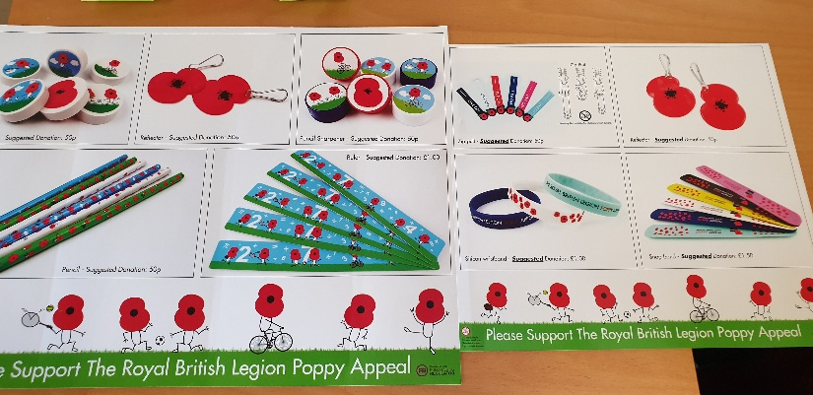
Attendance…
Attendance last week was 96.96% which is pretty impressive after a very long Half Term! I hope all the children have plenty of chance to rest next week and fight off any lingering germs.
Thank you…
We would like to say thank you to all our parents and carers for the respectful driving and parking in the vicinity of our school that we have seen demonstrated this week. We would also like to reiterate how proud we are of the way our pupils conduct themselves both at school and when outside representing our school. Our school is an integral part of our village and church community and we strive to help our children to feel safe, happy, confident, secure and inspired. We also work to help them develop an understanding of the difference between right and wrong, and a sense of personal responsibility within the school and wider community. Your contribution as role models outside of school is just as valuable as our teaching inside the school and we are grateful and thankful for this.

Your amazing response to ‘Bags to School’ raised £220! Film Friday raised £130; my thanks to you all and to the members of FAS for their hard work.

Residential…
Our residential is now confirmed for those children who have expressed an interest. We have 15 spaces booked from the 1 to 3 April. Letters for deposit payments will come out after Half Term.

With kind regards; have a wonderful Half Term!
Mrs Connolly

Autumn Diary Dates

Friday 25 October INSET day

Mon 28 October – Friday 1 November Half Term

Tuesday 5 November SETPOINT workshop – MATHS (UKS2)

Friday 8 November Open Morning

Friday 15 November Small Schools’ Football Tournament
(1 x KS2 6 a side team + subs)

FURTHER DATES ARE ON THE WEBSITE AND WILL BE SENT OUT AGAIN IN THE NEXT NEWSLETTER

Keeping in Touch…
Please do ensure you have signed up for the links below so you can keep in touch.

School Jotter:
Link to the app store - https://apple.co/2ITwmsm
Link to the android store - https://bit.ly/2GRPx3U

Alternatively, you can just search for School Jotter in your phone store or use the QR codes below.

We also have a new Facebook page: https://www.facebook.com/Ardeley-St-Lawrence-School-101246857959748
Please like & share!

Apple Android

