Ardeley St Lawrence C of E Primary School

Newsletter

11th October 2019

Dear Parents,
Good news…
Well done to these children who were awarded their merit certificate this week. They have all worked very hard:
RED: Leon, Felix
ORANGE: Santiago, Jack W, Parker

Both EYFS and KS1 have been to the farm this week, looking at animals and how they grow.
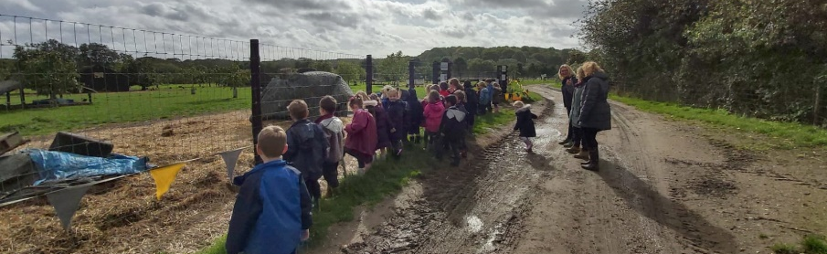

This afternoon LKS2 are making biscuits in Design technology.
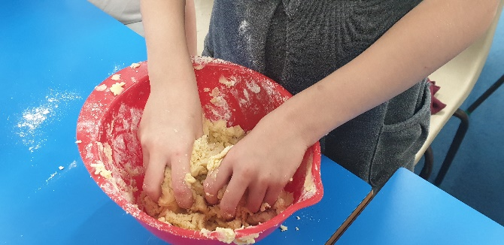

Yesterday UKS2 had great fun trying out the new tag rugby equipment with Mr Fitzgerald!
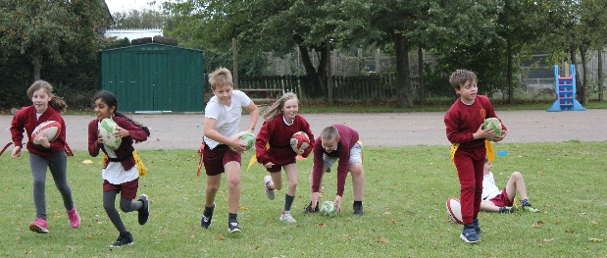

Events and dates…
School photos are on MONDAY!
If you would like a family photo involving pre-school siblings, please come after school.

BAGS TO SCHOOL is on Tuesday – please have a good clear out of clothes and bring them in bags to school for 9am on 15th October.
Film Friday is booked for the 18th October.

Parent Consultations are on 22 and 23 October. The WISEPAY system will go live tonight at approximately 6pm for bookings.

Our Open Morning in on Friday 8 November when the school will be open for any parents who may be thinking of sending their child to us in September 2020. You are welcome to look around for sibling admissions. Please spread the word – as always you are our best advert! The Open morning will run between 9.30 and 11.30am and our admissions arrangements are available on our school website.

Secondary School applications for our Y6 pupils need to be in by 31 October.

Keeping in Touch…
We try very hard to keep in touch with you and ensure you know what is going on. However, some parents have told us they don’t read the newsletters. We also post details of events on our website and have a linked app that you can put on your phone – this sends reminders as well as the weekly newsletter. We send reminders and information via Wisepay too. Please do ensure you have signed up for as many of these as possible so you can keep in touch.

The app is called School Jotter and these are the links:
Link to the app store - https://apple.co/2ITwmsm
Link to the android store - https://bit.ly/2GRPx3U

Alternatively, you can just search for School Jotter in your phone store or use the QR codes at the bottom of this newsletter.

We also have a new Facebook page: https://www.facebook.com/Ardeley-St-Lawrence-School-101246857959748
Please like & share!

Attendance…
Attendance last week was 97.6%. Keep it up!

Residential…
If your child is in KS2 please see the separate letter regarding the residential.

With kind regards

Mrs Connolly

Autumn Diary Dates

Monday 14 October School Photos - PM

Tuesday 15 October Bags to School
UKS2 Tudor Trip

Thursday 17 October LKS2 Museum Trip

Friday 18 October FAS Film Friday

Tuesday 22 October Parent Consultations

Wednesday 23 October Parent Consultations

Thursday 24 October Shoebox donation deadline

Friday 25 October INSET day

Mon 28 October – Friday 1 November Half Term

Tuesday 5 November SETPOINT workshop – MATHS (UKS2)

Friday 8 November Open Morning

Friday 15 November Small Schools’ Football Tournament
(1 x KS2 6 a side team + subs)

FURTHER DATES ARE ON THE WEBSITE

Apple Android

